MULTI-LINGUAL SIGN LANGUAGE TO SPEECH
AND SPEECH TO SIGN TRANSLATOR

A Project Report
Submitted in the partial fulfillment of the requirements for the award of the degree of

Master of Computer Applications
In

Department of Computer Science and Applications
By

Uppalapati Naveen Varma

(2401600155)
Under the supervision of
Mrs. Swathi Voddi
Professor


Department of Computer Science and Applications
K L E F, Green Fields,
Vaddeswaram, Guntur, Andhra Pradesh, India- 522502.
2025- 26

KONERU LAKSHMAIAH EDUCATION FOUNDATION

DEPARTMENT OF COMPUTER SCIENCE AND APPLICATIONS


DECLARATION

The Project Report entitled “MULTI-LINGUAL SIGN LANGUAGE TO SPEECH
AND SPEECH TO SIGN TRANSLATOR” is a record of bonafide work of Uppalapati Naveen Varma, submitted in partial fulfillment for the award of Master of Computer Applications in Computer Science and Applications of the K L University. The results embodied in this report have not been copied from any other departments/University/Institute.

Signature of the Student Uppalapati Naveen Varma (2401600155)

KONERU LAKSHMAIAH EDUCATION FOUNDATION DEPARTMENT OF COMPUTER SCIENCE AND APPLICATIONS


CERTIFICATE

This is to certify that the Project Report entitled “MULTI-LINGUAL SIGN LANGUAGE TO SPEECH
AND SPEECH TO SIGN TRANSLATOR” is being submitted by Uppalapati Naveen Varma, in partial fulfillment of the requirements for the award of Master of Computer Applications in Computer Science and Applications to the K L Education Foundation is a record of bonafide work carried out under our guidance and supervision. The results embodied in this report have not been copied from any other departments/ University/ Institute.

Signature of the Supervisor Signature of the HOD

(Dr. R.D. Sathiya) (Dr. G. Krishana Mohan) Professor Professor & HOD

Signature of the Examiner

ACKNOWLEDGEMENT

The satisfaction that accompanies the successful completion of any task would be incomplete without the mention of people who made it possible and whose constant guidance and encouragements crown all the efforts with success.

I am very thankful to our project guide Dr. R D Sathiya, Professor for her continuous support and encouragement in completing the Project work. Without her help the project couldn’t have been completed.

I express our heartful gratitude to Dr. G. Krishna Mohan, Head of the Department of Computer Science and Applications for providing us with adequate facilities, ways and means by which we are able to complete this project.

I express our heartful gratitude to Dr. K Subrahmanyam, Professor and Principal College of Sciences, for providing us with adequate facilities, ways and means by which we can complete this project.

Last but not the least, we thank all Teaching and Non-Teaching Staff of our department and especially my classmates and my friends for their support in the completion of our project.

Signature of the Student

Uppalapati Naveen Varma

(2401600155)

CONTENT PAGE NO
Abstract | 1
1.INTRODUCTION | 2
1.1 Motivation | 2
1.2 Problem Statement | 2
1.3 Objective of the Project | 2
1.4 Scope | 2
1.5 Project Introduction | 3
2.LTERATURE SURVEY | 4
2.1 Related Work | 4
3. SYSTEM ANALYSIS | 8
3.1 Existing System | 8
3.2 Disadvantages | 8
3.3 Proposed System | 8
3.4 Advantages | 8
3.5 work Flow of Proposed system | 9
4. REQUIREMENT ANALYSIS | 10
4.1 Function and non-functional requirements | 10
4.2 Hardware Requirements | 11
4.3 Software Requirements | 11
4.4 Architecture | 12
5. SYSTEM DESIGN | 13
5.1 Introduction of Input design | 13
5.2 UML Diagram (class, use case, sequence, collaborative, deployment, activity, ER diagram and Component diagram) | 15
5.3 Data Flow Diagram | 21
6. CODE, IMPLEMENTATION AND RESULTS | 23
6.1 Modules | 58
- SYSTEM STUDY AND TESTING | 64
7.1 Feasibility study | 64
7.2 Types of test & Test Cases | 65
8. CONCLUSION | 69
9. FUTURE ENHANCEMENT | 70
10. REFERENCES | 71

ABSTRACT:
This paper addresses security concerns in Ciphertext-policy attribute-based encryption (CP-ABE) for secure cloud data sharing. It tackles the key escrow problem by introducing a two-party key issuing protocol, preventing compromise by the key authority or cloud service provider. Additionally, the scheme enhances attribute expressiveness through weighted attributes, extending from binary to arbitrary states, reducing access policy complexity. This not only improves data sharing efficiency in cloud computing but also lowers storage costs and encryption complexity for cipher texts. The proposed solution ensures both security and efficiency, making it suitable for practical cloud applications.
keywords: secure data sharing, attribute-based encryption, removing escrow, cloud computing

- INTRODUCTION
1.1 Motivation:
The increasing reliance on cloud computing for data storage and sharing necessitates robust security measures to safeguard sensitive information. Ciphertext-policy attribute-based encryption (CP-ABE) offers a promising solution, but concerns such as the key escrow problem persist. Addressing this issue is crucial to instill trust in cloud-based systems, ensuring that sensitive data remains confidential and accessible only to authorized parties.
1.2 Problem Statement:
The key problem addressed is the vulnerability of CP-ABE in cloud data sharing, particularly the key escrow issue. This vulnerability poses a risk of compromise by the key authority or cloud service provider. Additionally, the existing attribute expressiveness is limited, hindering efficient data sharing. The paper addresses these challenges by introducing a two-party key issuing protocol and enhancing attribute expressiveness through weighted attributes, aiming to improve security, reduce access policy complexity, and enhance efficiency in cloud data sharing applications.
1.3 Objective of the project:
The objective of this project to enhance the security features for unauthorized decryption and unauthorized attribute manipulations on data while maintain the features of security. Aiming to make the system more secure and practical for use.
1.4 Scope:
This paper focuses on enhancing the security of Ciphertext-policy attribute-based encryption (CP-ABE) for cloud data sharing. It introduces a two-party key issuing protocol to mitigate the key escrow problem, ensuring security against compromises by the key authority or cloud service provider. The scheme also extends attribute expressiveness through weighted attributes, reducing access policy complexity and improving data sharing efficiency in cloud computing. The proposed

solution aims to address security challenges, enhance attribute expressiveness, and optimize efficiency, making it applicable to practical cloud applications.
1.5 Project Introduction:
In the rapidly evolving landscape of cloud computing, ensuring the security and privacy of shared data is paramount. Ciphertext-policy attribute-based encryption (CP-ABE) has emerged as a promising cryptographic technique for secure data sharing in the cloud. However, the persistent challenge of the key escrow problem threatens the integrity of CP-ABE systems, raising concerns about the confidentiality of sensitive information. This paper presents a novel approach to address these security concerns and enhance the efficiency of data sharing in cloud environments.
The key contribution of this work lies in the introduction of a two-party key issuing protocol, which effectively mitigates the key escrow problem inherent in CP-ABE systems. By distributing key issuance authority between two parties, namely the key authority and the cloud service provider, the protocol prevents any single entity from compromising the security of the system. This innovative solution ensures that sensitive data remains confidential and accessible only to authorized users, bolstering trust in cloud-based data sharing mechanisms.
Furthermore, the proposed scheme enhances attribute expressiveness through the incorporation of weighted attributes, allowing for finer granularity in access control policies. By extending attribute states from binary to arbitrary values, the complexity of access policies is reduced, thereby improving the efficiency of data sharing operations. This enhancement not only streamlines the process of data access management but also contributes to lower storage costs and reduced encryption complexity for ciphertexts.
In summary, the proposed solution offers a comprehensive approach to addressing security concerns in CP-ABE for secure cloud data sharing. By removing the key escrow problem, enhancing attribute expressiveness, and improving efficiency, this solution holds significant promise for practical applications in cloud computing environments.

2.LITERATURE SURVEY
2.1 Related Work:

[1] J. Baek, Q. H. Vu, J. K. Liu, X. Huang, and Y. Xiang. A secure cloud computing based framework for big data information management of smart grid. IEEE Transactions on Cloud Computing, 3(2):233–244, 2015.
This research introduces a secure cloud computing framework tailored for efficient big data management within smart grid systems. The objective is to address security concerns inherent in handling large volumes of data in smart grid environments. By leveraging cloud computing, the framework aims to enhance scalability and accessibility while ensuring data confidentiality, integrity, and availability.
The study likely employs a combination of encryption techniques, access control mechanisms, and data partitioning strategies to achieve its objectives. Specific algorithms may include encryption schemes like AES (Advanced Encryption Standard) for data protection and cryptographic protocols for secure communication between smart grid components and cloud servers.
The proposed framework offers several advantages, including improved data handling capabilities, enhanced security measures, and scalability to accommodate the growing demands of smart grid infrastructures. By leveraging cloud resources, it optimizes computational efficiency and storage management while maintaining robust security protocols.
The proposed system integrates cloud computing technologies with advanced security mechanisms to address the unique challenges of big data management in smart grid environments. It emphasizes the importance of confidentiality, integrity, and availability of data while ensuring scalability and accessibility for authorized users.
[2] A. Balu and K. Kuppusamy. An expressive and provably secure ciphertext-policy attribute-based encryption. Information Sciences, 276(4):354–362, 2014.
This research focuses on developing an expressive and provably secure ciphertext-policy attribute-based encryption (CP-ABE) system. The objective is to enable fine-grained access control over
encrypted data, where access policies are defined based on attributes associated with users and data.
The study likely utilizes cryptographic primitives such as bilinear pairings and mathematical

Structures like access trees or access structures to implement CP-ABE. Algorithms for key generation, encryption, and decryption are designed to support complex access policies while
ensuring security against unauthorized access.
The proposed CP-ABE system offers a flexible and scalable solution for data access control, allowing data owners to enforce access policies based on multiple attributes. It provides a high level of expressiveness, enabling precise control over who can access specific pieces of encrypted data while maintaining confidentiality.
The proposed system enhances data security and access control by employing CP-ABE, which allows for flexible and fine-grained access policies. It empowers data owners to enforce access control based on various attributes, facilitating secure data sharing and collaboration while preserving confidentiality.
Of course! Here's the content for the third reference:

[3] M. Belenkiy, J. Camenisch, M. Chase, M. Kohlweiss, A. Lysyanskaya, and H. Shacham. Randomizable proofs and delegatable anonymous credentials. Proceedings of the 29th Annual International Cryptology Conference, pages 108–125, 2009.
This project introduces randomizable proofs and delegatable anonymous credentials to enhance privacy and verifiability in cryptographic protocols. The objective is to provide a mechanism for proving statements about confidential information without revealing sensitive details.
The project employs cryptographic techniques such as zero-knowledge proofs and anonymous credentials. Algorithms for proof generation and verification are designed to ensure privacy while maintaining the integrity and authenticity of statements.
Randomizable proofs and delegatable anonymous credentials offer strong privacy guarantees, allowing users to prove statements about their attributes without disclosing sensitive information. This approach enhances privacy protection in various applications, including authentication and credential-based access control.
The proposed system integrates randomizable proofs and delegatable anonymous credentials to provide privacy-preserving authentication and authorization mechanisms. It enables users to prove their attributes anonymously while allowing verifiers to validate the authenticity of statements without compromising privacy.
[4] J. Bethencourt, A. Sahai, and B. Waters. Ciphertext-policy attribute-based encryption. IEEE Symposium on Security and Privacy, pages 321–334, 2007.

This project introduces ciphertext-policy attribute-based encryption (CP-ABE) to control access to encrypted data based on attributes. The aim is to provide a flexible and scalable access control

mechanism for secure data sharing.
The project utilizes mathematical structures like access trees and cryptographic primitives such as bilinear pairings. Algorithms for key generation, encryption, and decryption are designed to enforce access policies based on attributes.
CP-ABE offers fine-grained access control, enabling data owners to specify complex access policies based on attributes. This approach enhances data security and privacy, allowing selective access to encrypted data while maintaining confidentiality.
The proposed system implements CP-ABE to enforce access control policies based on attributes associated with users and data. It enables secure data sharing and collaboration while protecting sensitive information from unauthorized access.
[5] D. Boneh, B. Lynn, and H. Shacham. Short signatures from the weil pairing. Journal of Cryptology, 17(4):297–319, 2001.
This research presents a method for generating short digital signatures using the Weil pairing. The objective is to provide efficient and secure signature schemes suitable for resource-constrained environments.
The project employs mathematical techniques related to pairings on elliptic curves to construct short signature schemes. Algorithms for key generation, signing, and verification are optimized for efficiency.
Short signatures from the Weil pairing offer compact representations, reducing storage and communication overhead. Despite their size, these signatures provide strong security guarantees, making them suitable for various applications, including authentication and integrity verification.
The proposed system utilizes short signatures generated from the Weil pairing to provide efficient and secure authentication mechanisms. It offers lightweight cryptographic primitives suitable for constrained environments without compromising security.
[6] M. Chase. Multi-authority attribute based encryption. Proceedings of the 4th Conference on Theory of Cryptography, pages 515–534, 2007.
This project introduces multi-authority attribute-based encryption (MA-ABE) to enhance the scalability and flexibility of access control mechanisms. The objective is to distribute trust among

multiple authorities for managing access policies.

The project employs cryptographic techniques such as threshold cryptography and distributed key generation to enable collaboration among multiple authorities. Algorithms for key management and access policy enforcement are designed to operate in a distributed environment.

MA-ABE offers improved scalability and resilience by distributing trust and authority among multiple entities. It allows for more flexible access control policies while mitigating the risks associated with single points of failure.
The proposed system implements MA-ABE to facilitate secure and scalable access control in distributed environments. It enables collaboration among multiple authorities to manage access policies effectively while ensuring data confidentiality and integrity.

3. SYSTEM ANALYSIS
3.1 Existing System
The existing system employs Ciphertext-policy attribute-based encryption (CP-ABE) for secure cloud data sharing. However, it faces several challenges that need to be addressed. The key escrow problem is a significant concern, as the key authority or cloud service provider could compromise the security of the system. Additionally, the attribute expressiveness in the access policies is limited to binary states, which can lead to increased complexity in defining access policies. This can affect data sharing efficiency, raise storage costs, and complicate the encryption process for cipher texts.
3.2 Disadvantages
1. Key Escrow Vulnerability: The existing system is susceptible to the key escrow problem, posing a risk of compromise by the key authority or cloud service provider.
2. Limited Attribute Expressiveness: The binary attribute states in the access policies restrict the system's ability to efficiently represent complex access requirements.
3. Increased Access Policy Complexity: The binary attribute model may result in higher complexity when defining access policies, potentially affecting the usability of the system.
4. Higher Storage Costs: The limited attribute expressiveness and key escrow concerns may contribute to higher storage costs for managing encryption keys and access policies.
5. Encryption Complexity: The existing system's reliance on binary attribute states may lead to increased encryption complexity for cipher texts, impacting overall system efficiency.
3.3 Proposed System
The proposed system introduces a two-party key issuing protocol to address the key escrow problem and enhance security. It also extends attribute expressiveness by introducing weighted attributes, allowing for arbitrary attribute states. This extension aims to reduce access policy complexity, improving data sharing efficiency in cloud computing. Additionally, the proposed system aims to lower storage costs and simplify encryption complexity for cipher texts.
3.4 Advantages
1. Key Escrow Mitigation: The two-party key issuing protocol effectively mitigates the key escrow problem, enhancing the overall security of the system.

2.Enhanced Attribute Expressiveness: The introduction of weighted attributes allows for arbitrary

attribute states, reducing access policy complexity and increasing flexibility in defining access requirements.
3. Improved Data Sharing Efficiency: The proposed system is designed to enhance data sharing efficiency in cloud computing, leading to quicker and more streamlined sharing processes.
4.Lower Storage Costs: By addressing key escrow concerns and improving attribute expressiveness, the proposed system aims to reduce overall storage costs associated with encryption keys and access policies.
5.Simplified Encryption Complexity: The extension from binary to arbitrary attribute states contributes to simplified encryption processes for cipher texts, promoting efficiency in the encryption and decryption operations.

3.5 work Flow of Proposed system:
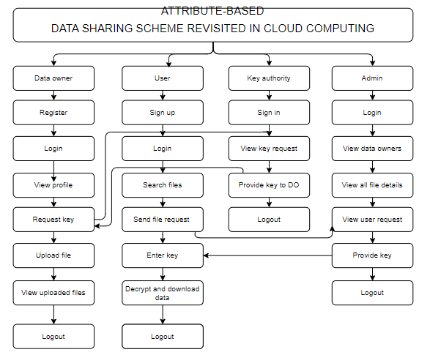

4. REQUIREMENT ANALYSIS
4.1 Functional and non-functional requirements
Requirement’s analysis is very critical process that enables the success of a system or software project to be assessed. Requirements are generally split into two types: Functional and non-functional requirements.
Functional Requirements: These are the requirements that the end user specifically demands as basic facilities that the system should offer. All these functionalities need to be necessarily incorporated into the system as a part of the contract. These are represented or stated in the form of input to be given to the system, the operation performed and the output expected. They are basically the requirements stated by the user which one can see directly in the final product, unlike the non-functional requirements.
Examples of functional requirements:
- Authentication of user whenever he/she logs into the system
- System shutdown in case of a cyber-attack
- A verification email is sent to user whenever he/she register for the first time on some software system.
Non-functional requirements: These are basically the quality constraints that the system must satisfy according to the project contract. The priority or extent to which these factors are implemented varies from one project to other. They are also called non-behavioral requirements.
They basically deal with issues like:
- Portability
- Security
- Maintainability
- Reliability
- Scalability
- Performance
- Reusability
- Flexibility

Examples of non-functional requirements:
- Emails should be sent with a latency of no greater than 12 hours from such an activity.

- The processing of each request should be done within 10 seconds
- The site should load in 3 seconds whenever of simultaneous users are > 10000
  - Hardware Requirements
Processor - I3/Intel Processor
Hard Disk - 160GB
Key Board - Standard Windows Keyboard
Mouse - Two or Three Button Mouse
Monitor - SVGA
RAM - 8GB
  - Software Requirements:
Operating System : Windows 7/8/10
Server-side Script : HTML, CSS, Bootstrap & JS
Programming Language : Python
Libraries : Flask, Pandas, Mysql.connector, Os, Smtplib, Numpy
IDE/Workbench : PyCharm
Technology : Python 3.6+
Server Deployment : Xampp Server
Database : MySQL

4.4Architecture:

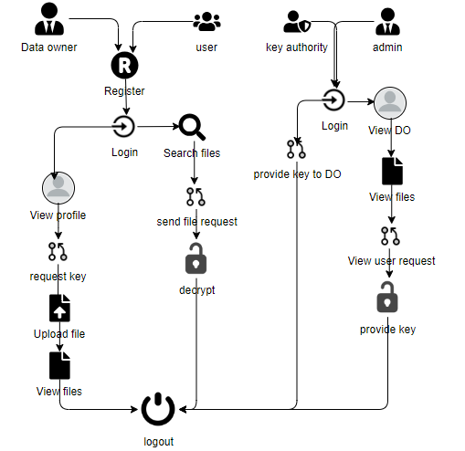

5. SYSTEM DESIGN
5.1 Introduction of Input Design:
In an information system, input is the raw data that is processed to produce output. During the input design, the developers must consider the input devices such as PC, MICR, OMR, etc.
Therefore, the quality of system input determines the quality of system output. Well-designed input forms and screens have following properties −
- It should serve specific purpose effectively such as storing, recording, and retrieving the information.
- It ensures proper completion with accuracy.
- It should be easy to fill and straightforward.
- It should focus on user’s attention, consistency, and simplicity.
- All these objectives are obtained using the knowledge of basic design principles regarding −
  - What are the inputs needed for the system?
  - How end users respond to different elements of forms and screens.

Objectives for Input Design:
The objectives of input design are −
- To design data entry and input procedures
- To reduce input volume
- To design source documents for data capture or devise other data capture methods
- To design input data records, data entry screens, user interface screens, etc.
- To use validation checks and develop effective input controls.

Output Design:

The design of output is the most important task of any system. During output design, developers identify the type of outputs needed, and consider the necessary output controls and prototype report layouts.

Objectives of Output Design:
The objectives of input design are:
- To develop output design that serves the intended purpose and eliminates the production of unwanted output.
- To develop the output design that meets the end user’s requirements.
- To deliver the appropriate quantity of output.
- To form the output in appropriate format and direct it to the right person.
- To make the output available on time for making good decisions.

5.2 UML Diagrams:
5.2.1 Use Case Diagram:
A use case diagram in the Unified Modeling Language (UML) is a type of behavioral diagram defined by and created from a Use-case analysis. Its purpose is to present a graphical overview of the functionality provided by a system in terms of actors, their goals (represented as use cases), and any dependencies between those use cases. The main purpose of a use case diagram is to show what system functions are performed for which actor. Roles of the actors in the system can be depicted.
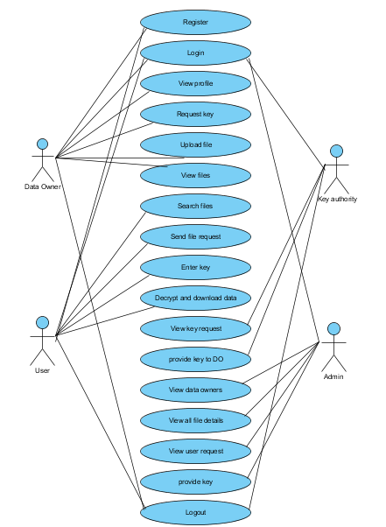

5.2.2 Class Diagram:
In software engineering, a class diagram in the Unified Modelling Language (UML) is a type of static structure diagram that describes the structure of a system by showing the system's classes, their attributes, operations (or methods), and the relationships among the classes. It explains which class contains information.
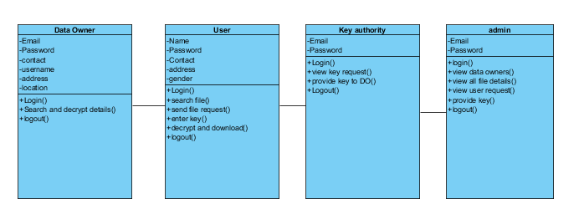

5.2.3 Sequence Diagram:
A sequence diagram in Unified Modelling Language (UML) is a kind of interaction diagram that shows how processes operate with one another and in what order. It is a construct of a Message Sequence Chart. Sequence diagrams are sometimes called event diagrams, event scenarios, and timing diagrams.

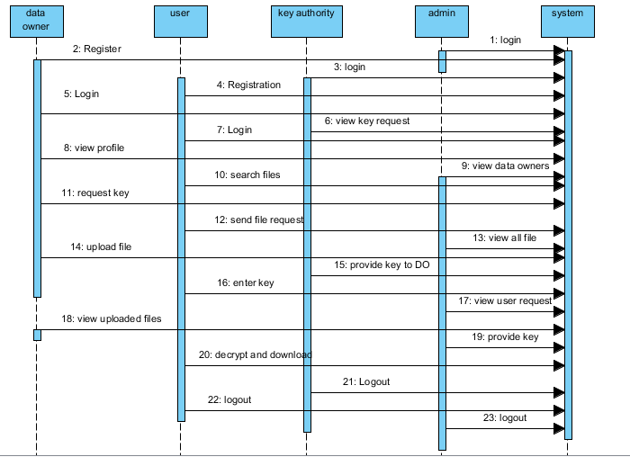

5.2.4 Collaboration Diagram:
In collaboration diagram the method call sequence is indicated by some numbering technique as shown below. The number indicates how the methods are called one after another. We have taken the same order management system to describe the collaboration diagram. The method calls are similar to that of a sequence diagram. But the difference is that the sequence diagram does not describe the object organization whereas the collaboration diagram shows the object organization.
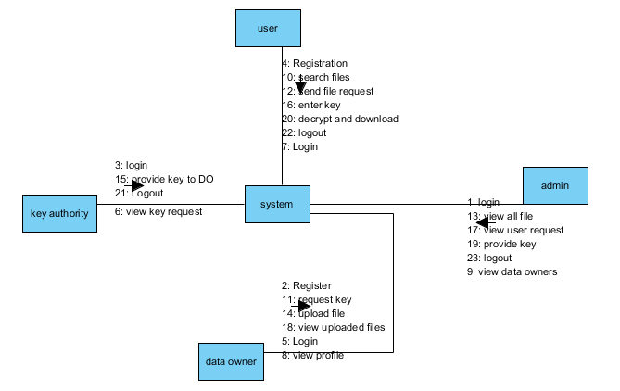
5.2.5 Deployment Diagram
Deployment diagram represents the deployment view of a system. It is related to the component diagram. Because the components are deployed using the deployment diagrams. A deployment diagram consists of nodes. Nodes are nothing but physical hardware’s used to deploy the application. 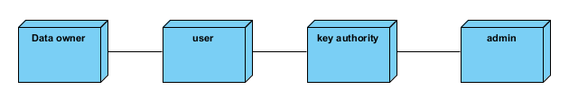

5.2.6 Activity Diagram:
Activity diagrams are graphical representations of workflows of stepwise activities and actions with support for choice, iteration and concurrency. In the Unified Modelling Language, activity diagrams can be used to describe the business and operational step-by-step workflows of components in a system. An activity diagram shows the overall flow of control.
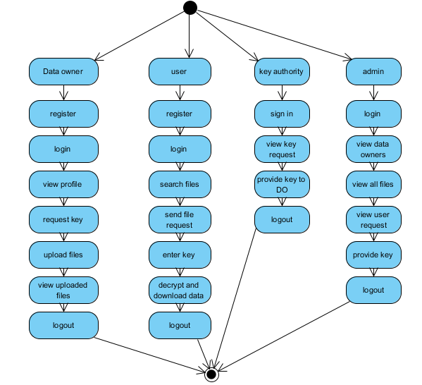

5.2.7 Component Diagram:
A component diagram, also known as a UML component diagram, describes the organization and wiring of the physical components in a system. Component diagrams are often drawn to help model implementation details and double-check that every aspect of the system's required functions is covered by planned development.
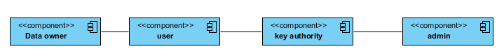

5.2.8 ER Diagram:
An Entity–relationship model (ER model) describes the structure of a database with the help of a diagram, which is known as Entity Relationship Diagram (ER Diagram). An ER model is a design or blueprint of a database that can later be implemented as a database. The main components of E-R model are: entity set and relationship set.
An ER diagram shows the relationship among entity sets. An entity set is a group of similar entities and these entities can have attributes. In terms of DBMS, an entity is a table or attribute of a table in database, so by showing relationship among tables and their attributes, ER diagram shows the complete logical structure of a database. Let’s have a look at a simple ER diagram to understand this concept.

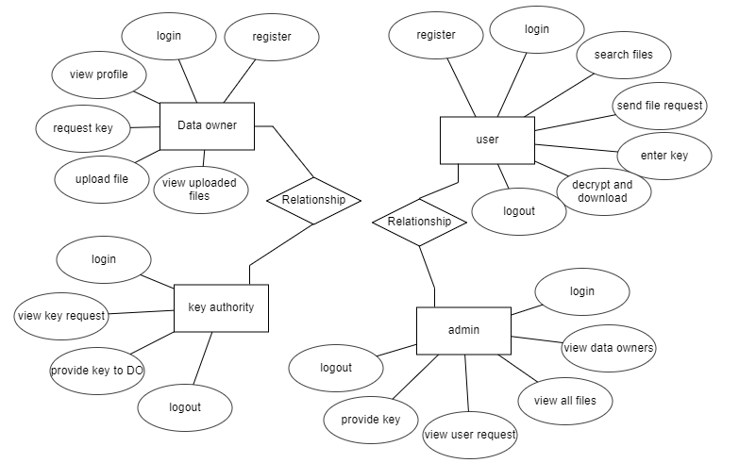

5.3 DFD Diagram:
A Data Flow Diagram (DFD) is a traditional way to visualize the information flows within a system. A neat and clear DFD can depict a good amount of the system requirements graphically. It can be

manual, automated, or a combination of both. It shows how information enters and leaves the system, what changes the information and where information is stored. The purpose of a DFD is to show the scope and boundaries of a system as a whole. It may be used as a communications tool between a systems analyst and any person who plays a part in the system that acts as the starting point for redesigning a system.

Level 0 Diagram:

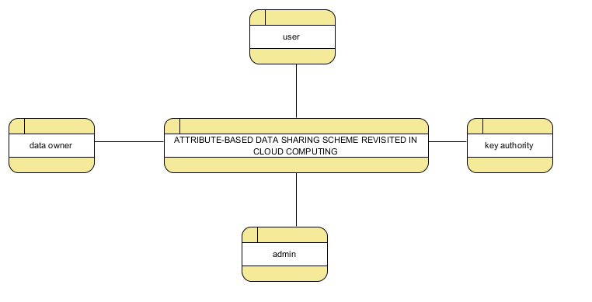

Level 1 Diagram:

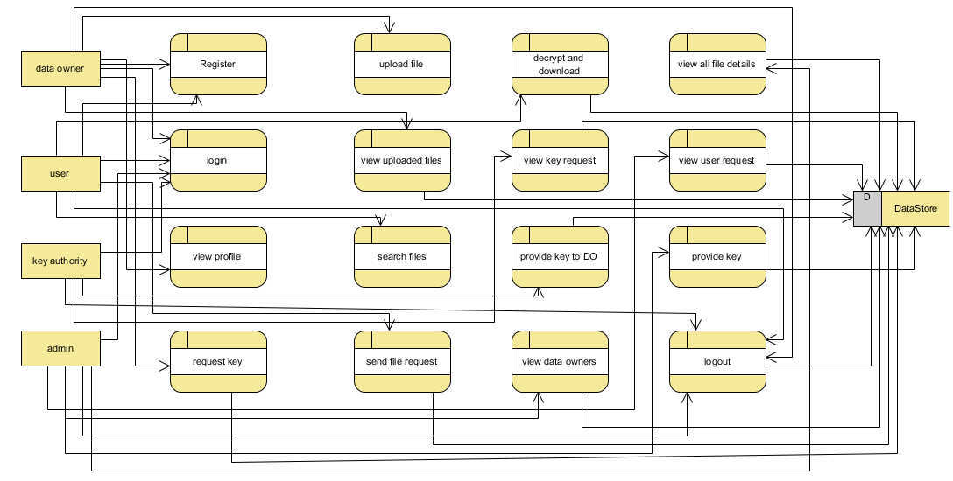

Level 2 Diagram:

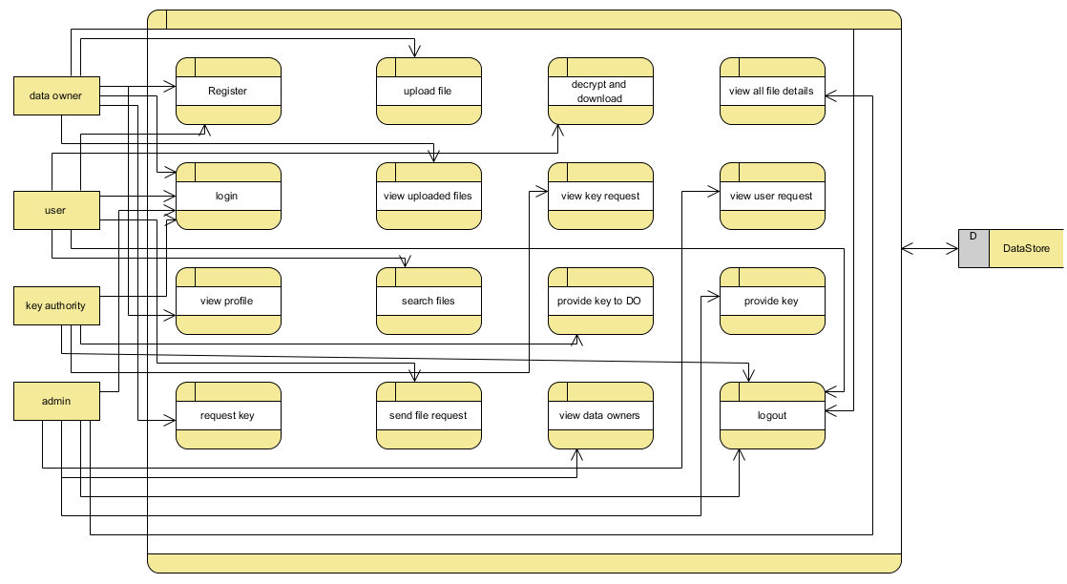

6.CODE, IMPLEMENTATION AND RESULT
CLOUDHOME.HTML :-
<!DOCTYPE html>
<html>

<head>
<!-- Basic -->
<meta charset="utf-8" />
<meta http-equiv="X-UA-Compatible" content="IE=edge" />
<!-- Mobile Metas -->
<meta name="viewport" content="width=device-width, initial-scale=1, shrink-to-fit=no" />
<!-- Site Metas -->
<meta name="keywords" content="" />
<meta name="description" content="" />
<meta name="author" content="" />

<title>Intot</title>

<!-- slider stylesheet -->
<link rel="stylesheet" type="text/css"
href="https://cdnjs.cloudflare.com/ajax/libs/OwlCarousel2/2.1.3/assets/owl.carousel.min.css" />

<!-- bootstrap core css -->
<link rel="stylesheet" type="text/css" href="/static/css/bootstrap.css" />

<!-- fonts style -->
<link href="https://fonts.googleapis.com/css?family=Dosis:400,500|Poppins:400,600,700&display=swap" rel="stylesheet">
<!-- Custom styles for this template -->
<link href="/static/css/style.css" rel="stylesheet" />
<!-- responsive style -->
<link href="/static/css/responsive.css" rel="stylesheet" />
</head>

<body>
<div class="hero_area">
<!-- header section strats -->
<header class="header_section">
<div class="container-fluid">
<nav class="navbar navbar-expand-lg custom_nav-container">
<a class="navbar-brand" href="index.html">
<span>
MULTI-LINGUAL SIGN LANGUAGE TO SPEECH
AND SPEECH TO SIGN TRANSLATOR

</span>
</a>

<div class="navbar-collapse" id="">
<div class="d-none d-lg-flex ml-auto flex-column flex-lg-row align-items-center">

<!-- <form class="form-inline my-2 mb-3 mb-lg-0 mr-5">
<button class="btn my-2 my-sm-0 nav_search-btn" type="submit"></button>
</form> -->
</div>

<div class="custom_menu-btn">
<button onclick="openNav()">
<span class="s-1">

</span>
<span class="s-2">

</span>
<span class="s-3">

</span>
</button>
</div>
<div id="myNav" class="overlay">
<div class="overlay-content">
<a href="{{url_for('viewowner')}}" >View Data Owner</a>
<a href="{{url_for('viewuser')}}">View Data User</a>
<a href="{{url_for('viewallfile')}}">View all files</a>
<a href="{{url_for('viewequest')}}">Key Description</a>
<a href="/">Logout</a>

</div>
</div>
</div>
</nav>
</div>
</header>
<!-- end header section -->
<!-- slider section -->
<section class=" slider_section position-relative">
<div id="carouselExampleIndicators" class="carousel slide" data-ride="carousel">
<div class="carousel-inner">

<div class="carousel-item active">
<div class="row">
<div class="col-md-3 offset-md-2">
<div class="slider_detail">
<h1>
Welcome to
<span>
Cloud homepage
</span>
</h1>
<p>

</p>
<div>
</div>
</div>
</div>
<div class="col-md-7">
<div class="slider_img-box">
<img src="/static/images/slider-img.png" alt="">
</div>
</div>
</div>
</div>
</div>
</div>

</section>

<!-- end slider section -->
</div>

<!-- end info section -->
<hr class="footer_hr">
<!-- footer section -->
<section class="container-fluid footer_section">
<p>
&copy;
2019 All Rights Reserved. Design by
<a href="https://html.design/">Free Html Templates</a>
</p>
</section>
<!-- footer section -->

<script type="text/javascript" src="/static/js/jquery-3.4.1.min.js"></script>
<script type="text/javascript" src="/static/js/bootstrap.js"></script>

<script>
function openNav() {
document.getElementById("myNav").classList.toggle("menu_width")
document.querySelector(".custom_menu-btn").classList.toggle("menu_btn-style")
}
</script>
</body>

</html>

CLOUDLOGIN.HTML:

<!DOCTYPE html>
<html>

<head>
<!-- Basic -->
<meta charset="utf-8" />
<meta http-equiv="X-UA-Compatible" content="IE=edge" />
<!-- Mobile Metas -->
<meta name="viewport" content="width=device-width, initial-scale=1, shrink-to-fit=no" />
<!-- Site Metas -->
<meta name="keywords" content="" />
<meta name="description" content="" />
<meta name="author" content="" />

<title>Intot</title>

<!-- slider stylesheet -->
<link rel="stylesheet" type="text/css"
href="https://cdnjs.cloudflare.com/ajax/libs/OwlCarousel2/2.1.3/assets/owl.carousel.min.css" />
<!-- bootstrap core css -->
<link rel="stylesheet" type="text/css" href="/static/css/bootstrap.css" />
<!-- fonts style -->
<link href="https://fonts.googleapis.com/css?family=Dosis:400,500|Poppins:400,600,700&display=swap" rel="stylesheet">
<!-- Custom styles for this template -->
<link href="/static/css/style.css" rel="stylesheet" />

<!-- responsive style -->

<link href="/static/css/responsive.css" rel="stylesheet" />

</head>

<body class="sub_page">

<body class="">
<div class="hero_area">
<!-- header section strats -->
<header class="header_section">
<div class="container-fluid">
<nav class="navbar navbar-expand-lg custom_nav-container">
<a class="navbar-brand" href="index.html">
<span>
CLOUD COMPUTING
</span>
</a>

<div class="navbar-collapse" id="">
<div class="d-none d-lg-flex ml-auto flex-column flex-lg-row align-items-center">

<form class="form-inline my-2 mb-3 mb-lg-0 mr-5">
<button class="btn my-2 my-sm-0 nav_search-btn" type="submit"></button>
</form>
</div>

<div class="custom_menu-btn">
<button onclick="openNav()">
<span class="s-1">

</span>
<span class="s-2">

</span>
<span class="s-3">
</span>
</button>
</div>
<div id="myNav" class="overlay">
<div class="overlay-content">
<a href="{{url_for('dataownerlogin')}}" >Data Owner</a>

<a href="{{url_for('datauserlogin')}}">Data User</a>
<a href="{{url_for('tpalogin')}}">Key Authority</a>
<a href="{{url_for('cloudlogin')}}">Admin/Cloud</a>

</div>
</div>
</div>
</nav>
</div>
</header>
<!-- end header section -->
</div>
<!-- contact section -->
<section class="contact_section layout_padding">
<div class="container">
<h2 class="">
Cloud Login
</h2>
</div>
<div class="container">

<div class="row">
<div class="col-md-6 " style="
left: 298px;
">
<center> <form action="{{ url_for('cloudlogin') }}" class="hero-form" method="post" enctype="multipart/form-data">
<div class="contact_form-container">
<div>
<div>
<label>
<input type="email" class="form-control bg-dark border-0 px-4" name="cloudemail" id="cloudemail" placeholder="Enter email" style="height: 55px;border-radius:20px;">
</label>
</div>
<div>
<label>
<input type="password" class="form-control bg-dark border-0 px-4" name="password" id="password" placeholder="Enter Password" style="height: 55px;border-radius:20px;">
</label>
</div>
<div class="mt-5">
<button type="submit">

Send
</button>

</div>

</div>
</div>
</form>
</div>
</div>
</div>
</section>
<!-- end contact section -->
<script type="text/javascript" src="/static/js/jquery-3.4.1.min.js"></script>
<script type="text/javascript" src="/static/js/bootstrap.js"></script>
<script>
function openNav() {
document.getElementById("myNav").classList.toggle("menu_width")
document.querySelector(".custom_menu-btn").classList.toggle("menu_btn-style")
}
</script>
</body>
</html>

DOWN.HTML:

<!DOCTYPE html>
<html>
<head>
<!-- Basic -->
<meta charset="utf-8" />
<meta http-equiv="X-UA-Compatible" content="IE=edge" />
<!-- Mobile Metas -->
<meta name="viewport" content="width=device-width, initial-scale=1, shrink-to-fit=no" />
<!-- Site Metas -->
<meta name="keywords" content="" />
<meta name="description" content="" />
<meta name="author" content="" />

<title>Intot</title>

<!-- slider stylesheet -->

<link rel="stylesheet" type="text/css"

href="https://cdnjs.cloudflare.com/ajax/libs/OwlCarousel2/2.1.3/assets/owl.carousel.min.css" />

<!-- bootstrap core css -->
<link rel="stylesheet" type="text/css" href="/static/css/bootstrap.css" />

<!-- fonts style -->
<link href="https://fonts.googleapis.com/css?family=Dosis:400,500|Poppins:400,600,700&display=swap" rel="stylesheet">
<!-- Custom styles for this template -->
<link href="/static/css/style.css" rel="stylesheet" />
<!-- responsive style -->
<link href="/static/css/responsive.css" rel="stylesheet" />
</head>

<body class="sub_page">

<body class="">
<div class="hero_area">
<!-- header section strats -->
<header class="header_section">
<div class="container-fluid">
<nav class="navbar navbar-expand-lg custom_nav-container">
<a class="navbar-brand" href="index.html">
<span>
CLOUD COMPUTING
</span>
</a>

<div class="navbar-collapse" id="">
<div class="d-none d-lg-flex ml-auto flex-column flex-lg-row align-items-center">

<form class="form-inline my-2 mb-3 mb-lg-0 mr-5">
<button class="btn my-2 my-sm-0 nav_search-btn" type="submit"></button>
</form>
</div>

<div class="custom_menu-btn">
<button onclick="openNav()">
<span class="s-1">

</span>
<span class="s-2">

</span>
<span class="s-3">

</span>
</button>
</div>
<div id="myNav" class="overlay">

<div class="overlay-content">
<a href="{{url_for('search')}}">Search file</a>
<a href="{{url_for('viewkeydetails')}}" >Key Details</a>
<a href="{{url_for('download')}}">Download files</a>
<a href="/">Logout</a>

</div>
</div>
</div>
</nav>
</div>
</header>
<!-- end header section -->
</div>
<!-- contact section -->
<section class="contact_section layout_padding">
<div class="container">
<h2 class="">
Download Files
</h2>
</div>
<div class="container">
<div class="row">
<div class="col-md-6 " style="
left: 298px;
">
<center> <form action="{{ url_for('readkey') }}" class="hero-form" method="post" enctype="multipart/form-data">
<div class="contact_form-container">
<input type="hidden" name="id" value="{{id}}">
<div>
<div>
<label>
<input type="text" class="form-control bg-dark border-0 px-4" name="Secratekey1" id="Secratekey1" placeholder="Enter key1" style="height: 55px;border-radius:20px;">

</label>

</div>
\
<div>
<label>
<input type="text" class="form-control bg-dark border-0 px-4" name="Secratekey2" id="Secratekey2" placeholder="Enter Key2" style="height: 55px;border-radius:20px;">
</label>
</div>

<div class="mt-5">
<button type="submit">
Download
</button>
</div>

</div>
</div>
</form>
</div>
</div>
</div>
</section>
<!-- end contact section -->
<script type="text/javascript" src="/static/js/jquery-3.4.1.min.js"></script>
<script type="text/javascript" src="/static/js/bootstrap.js"></script>
<script>
function openNav() {
document.getElementById("myNav").classList.toggle("menu_width")
document.querySelector(".custom_menu-btn").classList.toggle("menu_btn-style")
}
</script>
</body>

</html>

DOWNLOAD.HTML:

<!DOCTYPE html>
<html>
<head>
<!-- Basic -->

<meta charset="utf-8" />
<meta http-equiv="X-UA-Compatible" content="IE=edge" />
<!-- Mobile Metas -->

<meta name="viewport" content="width=device-width, initial-scale=1, shrink-to-fit=no" />
<!-- Site Metas -->
<meta name="keywords" content="" />
<meta name="description" content="" />
<meta name="author" content="" />

<title>Intot</title>

<!-- slider stylesheet -->
<link rel="stylesheet" type="text/css"
href="https://cdnjs.cloudflare.com/ajax/libs/OwlCarousel2/2.1.3/assets/owl.carousel.min.css" />

<!-- bootstrap core css -->
<link rel="stylesheet" type="text/css" href="/static/css/bootstrap.css" />

<!-- fonts style -->
<link href="https://fonts.googleapis.com/css?family=Dosis:400,500|Poppins:400,600,700&display=swap" rel="stylesheet">
<!-- Custom styles for this template -->
<link href="/static/css/style.css" rel="stylesheet" />
<!-- responsive style -->
<link href="/static/css/responsive.css" rel="stylesheet" />
</head>

<body class="sub_page">

<body class="">
<div class="hero_area">
<!-- header section strats -->
<header class="header_section">
<div class="container-fluid">
<nav class="navbar navbar-expand-lg custom_nav-container">
<a class="navbar-brand" href="index.html">
<span>
CLOUD COMPUTING
</span>
</a>

<div class="navbar-collapse" id="">

<div class="d-none d-lg-flex ml-auto flex-column flex-lg-row align-items-center">

<form class="form-inline my-2 mb-3 mb-lg-0 mr-5">
<button class="btn my-2 my-sm-0 nav_search-btn" type="submit"></button>
</form>

</div>

<div class="custom_menu-btn">
<button onclick="openNav()">
<span class="s-1">

</span>
<span class="s-2">

</span>
<span class="s-3">

</span>
</button>
</div>
<div id="myNav" class="overlay">
<div class="overlay-content">
<a href="{{url_for('search')}}">Search file</a>
<a href="{{url_for('viewkeydetails')}}" >Key Details</a>
<a href="{{url_for('download')}}">Download files</a>
<a href="/">Logout</a>

</div>
</div>
</div>
</nav>
</div>
</header>
<!-- end header section -->
</div>
<center>
<h1 class="section-title bg-white text-center text-primary px-3">
VIEW Secure Keys
</h1>
</center><br><br>
<center style="

width: 1786px;
">
<div class="container text-center">
<table class="table">
<thead>
<tr>
<th>Id</th>

<th>Filename</th>
<th>Encrypted Data</th>
<th>key1</th>
<th>Key2</th>
<th>Action</th>
</tr>
</thead>
<tbody>
{% for row in row_val %}

<tr>
<td>{{ row[0] }}</td>

<td>{{ row[3] }}</td>
<td>{{ row[4] }}</td>
<td>{{ row[5] }}</td>
<td>{{ row[6] }}</td>
<td><a style="color:rgb(0, 195, 140);" href="{{ url_for('down', id=row[0],filename=row[3]) }}" type="submit">Download File</a></td>
</tr>
{% endfor %}
</tbody>
</table>
</div>
</center>
<!-- end contact section -->
<script type="text/javascript" src="/static/js/jquery-3.4.1.min.js"></script>
<script type="text/javascript" src="/static/js/bootstrap.js"></script>
<script>
function openNav() {
document.getElementById("myNav").classList.toggle("menu_width")
document.querySelector(".custom_menu-btn").classList.toggle("menu_btn-style")
}
</script>
</body>

</html>

INDEX.HTML:

<!DOCTYPE html>
<html>

<head>

<!-- Basic -->
<meta charset="utf-8" />
<meta http-equiv="X-UA-Compatible" content="IE=edge" />
<!-- Mobile Metas -->
<meta name="viewport" content="width=device-width, initial-scale=1, shrink-to-fit=no" />
<!-- Site Metas -->
<meta name="keywords" content="" />
<meta name="description" content="" />
<meta name="author" content="" />

<title>Intot</title>

<!-- slider stylesheet -->
<link rel="stylesheet" type="text/css"
href="https://cdnjs.cloudflare.com/ajax/libs/OwlCarousel2/2.1.3/assets/owl.carousel.min.css" />

<!-- bootstrap core css -->
<link rel="stylesheet" type="text/css" href="/static/css/bootstrap.css" />

<!-- fonts style -->
<link href="https://fonts.googleapis.com/css?family=Dosis:400,500|Poppins:400,600,700&display=swap" rel="stylesheet">
<!-- Custom styles for this template -->
<link href="/static/css/style.css" rel="stylesheet" />
<!-- responsive style -->
<link href="/static/css/responsive.css" rel="stylesheet" />
</head>

<body>
<div class="hero_area">
<!-- header section strats -->
<header class="header_section">
<div class="container-fluid">
<nav class="navbar navbar-expand-lg custom_nav-container">

<a class="navbar-brand" href="index.html">
<span>
CLOUD COMPUTING
</span>
</a>

<div class="navbar-collapse" id="">
<div class="d-none d-lg-flex ml-auto flex-column flex-lg-row align-items-center">
<!-- <form class="form-inline my-2 mb-3 mb-lg-0 mr-5">
<button class="btn my-2 my-sm-0 nav_search-btn" type="submit"></button>

</form> -->
</div>

<div class="custom_menu-btn">
<button onclick="openNav()">
<span class="s-1">

</span>
<span class="s-2">

</span>

<span class="s-3">

</span>
</button>
</div>
<div id="myNav" class="overlay">
<div class="overlay-content">
<a href="{{url_for('dataownerlogin')}}" >Data Owner</a>
<a href="{{url_for('datauserlogin')}}">Data User</a>
<a href="{{url_for('tpalogin')}}">Key Authority</a>
<a href="{{url_for('cloudlogin')}}">Admin/Cloud</a>
</div>
</div>
</div>
</nav>
</div>
</header>
<!-- end header section -->
<!-- slider section -->
<section class=" slider_section position-relative">

<div id="carouselExampleIndicators" class="carousel slide" data-ride="carousel">
<div class="carousel-inner">
<div class="carousel-item active">
<div class="row">
<div class="col-md-3 offset-md-2">
<div class="slider_detail">
<h1>
ATTRIBUTE-BASED DATA SHARING SCHEME
<span>
REVISITED IN CLOUD COMPUTING
</span>

</h1>
<p>

</p>
<div>
</div>
</div>
</div>
<div class="col-md-7">
<div class="slider_img-box">
<img src="/static/images/slider-img.png" alt="">
</div>

</div>
</div>
</div>
</div>
</div>

</section>

<!-- end slider section -->
</div>

<!-- end info section -->
<hr class="footer_hr">
<!-- footer section -->
<section class="container-fluid footer_section">
<p>
&copy;
2019 All Rights Reserved. Design by

<a href="https://html.design/">Free Html Templates</a>
</p>
</section>
<!-- footer section -->

<script type="text/javascript" src="/static/js/jquery-3.4.1.min.js"></script>
<script type="text/javascript" src="/static/js/bootstrap.js"></script>
<script>
function openNav() {
document.getElementById("myNav").classList.toggle("menu_width")
document.querySelector(".custom_menu-btn").classList.toggle("menu_btn-style")
}
</script>

</body>

</html>
KEYREQUEST.HTML:

<!DOCTYPE html>
<html>
<head>
<!-- Basic -->
<meta charset="utf-8" />
<meta http-equiv="X-UA-Compatible" content="IE=edge" />
<!-- Mobile Metas -->
<meta name="viewport" content="width=device-width, initial-scale=1, shrink-to-fit=no" />
<!-- Site Metas -->
<meta name="keywords" content="" />
<meta name="description" content="" />
<meta name="author" content="" />
<title>Intot</title>
<!-- slider stylesheet -->
<link rel="stylesheet" type="text/css"
href="https://cdnjs.cloudflare.com/ajax/libs/OwlCarousel2/2.1.3/assets/owl.carousel.min.css" />
<!-- bootstrap core css -->
<link rel="stylesheet" type="text/css" href="/static/css/bootstrap.css" />
<!-- fonts style -->
<link href="https://fonts.googleapis.com/css?family=Dosis:400,500|Poppins:400,600,700&display=swap" rel="stylesheet">
<!-- Custom styles for this template -->
<link href="/static/css/style.css" rel="stylesheet" />
<!-- responsive style -->
<link href="/static/css/responsive.css" rel="stylesheet" />
</head>
<body class="sub_page">
<body class="">
<div class="hero_area">
<!-- header section strats -->
<header class="header_section">
<div class="container-fluid">
<nav class="navbar navbar-expand-lg custom_nav-container">
<a class="navbar-brand" href="index.html">
<span>
CLOUD COMPUTING
</span>
</a>
<div class="navbar-collapse" id="">
<div class="d-none d-lg-flex ml-auto flex-column flex-lg-row align-items-center">
<form class="form-inline my-2 mb-3 mb-lg-0 mr-5">
<button class="btn my-2 my-sm-0 nav_search-btn" type="submit"></button>
</form>
</div>
<div class="custom_menu-btn">
<button onclick="openNav()">
<span class="s-1">
</span>
<span class="s-2">
</span>
<span class="s-3">
</span>
</button>
</div>
<div id="myNav" class="overlay">
<div class="overlay-content">
<a href="{{url_for('viewprofile')}}" >Profile</a>
<a href="{{url_for('keyrequest')}}">Request Key</a>
<a href="{{url_for('upload')}}">Upload File</a>
<a href="{{url_for('viewmyfile')}}">File Deatils</a>
<a href="/">Logout</a>
</div>
</div>
</div>
</nav>
</div>
</header>
<!-- end header section -->
</div>
<center>
<h1 class="section-title bg-white text-center text-primary px-3">
Key Request
</h1>
</center><br><br>
<center> <div class="container text-center">
<div class="row align-items-start" >
{% for row in row_val %}
<div class="col" >
<div class="card" style="width: 22rem;border-radius:20px;left: 384px;">
<div class="card-body">
<b><p class="news_taital" style="color:black;">
Name : {{row[1]}}
</p></b>
<p class="long_text" style="color:black;">
Email: {{row[2]}}
</p>
<p class="long_text" style="color:black;">
Password: {{row[3]}}
</p>
<p class="long_text" style="color:black;">
Contact Number: {{row[4]}}
</p>
<p class="long_text" style="color:black;">
Address: {{row[5]}}
</p>
<p class="long_text" style="color:black;">
Master_key: {{row[6]}}
</p>
<a style="color:rgb(0, 195, 140);" href="{{ url_for('requestkey', id=row[0]) }}" type="submit">Request key</a>
</div>
</div>
</div>
{% endfor %}
</div>
</div></center>
<!-- end contact section -->
<script type="text/javascript" src="/static/js/jquery-3.4.1.min.js"></script>
<script type="text/javascript" src="/static/js/bootstrap.js"></script>
<script>
function openNav() {
document.getElementById("myNav").classList.toggle("menu_width")
document.querySelector(".custom_menu-btn").classList.toggle("menu_btn-style")
}
</script>
</body>
</html>

OWNERHOME.HTML:

<!DOCTYPE html>
<html>
<head>
<!-- Basic -->
<meta charset="utf-8" />
<meta http-equiv="X-UA-Compatible" content="IE=edge" />
<!-- Mobile Metas -->
<meta name="viewport" content="width=device-width, initial-scale=1, shrink-to-fit=no" />
<!-- Site Metas -->
<meta name="keywords" content="" />
<meta name="description" content="" />
<meta name="author" content="" />
<title>Intot</title>
<!-- slider stylesheet -->
<link rel="stylesheet" type="text/css"
href="https://cdnjs.cloudflare.com/ajax/libs/OwlCarousel2/2.1.3/assets/owl.carousel.min.css" />
<!-- bootstrap core css -->
<link rel="stylesheet" type="text/css" href="/static/css/bootstrap.css" />
<!-- fonts style -->
<link href="https://fonts.googleapis.com/css?family=Dosis:400,500|Poppins:400,600,700&display=swap" rel="stylesheet">
<!-- Custom styles for this template -->
<link href="/static/css/style.css" rel="stylesheet" />
<!-- responsive style -->
<link href="/static/css/responsive.css" rel="stylesheet" />
</head>
<body>
<div class="hero_area">
<!-- header section strats -->
<header class="header_section">
<div class="container-fluid">
<nav class="navbar navbar-expand-lg custom_nav-container">
<a class="navbar-brand" href="index.html">
<span>
MULTI-LINGUAL SIGN LANGUAGE TO SPEECH
AND SPEECH TO SIGN TRANSLATOR
</span>
</a>
<div class="navbar-collapse" id="">
<div class="d-none d-lg-flex ml-auto flex-column flex-lg-row align-items-center">
<!-- <form class="form-inline my-2 mb-3 mb-lg-0 mr-5">
<button class="btn my-2 my-sm-0 nav_search-btn" type="submit"></button>

</form> -->
</div>
<div class="custom_menu-btn">
<button onclick="openNav()">
<span class="s-1">
</span>
<span class="s-2">
</span>
<span class="s-3">
</span>
</button>
</div>
<div id="myNav" class="overlay">
<div class="overlay-content">
<a href="{{url_for('viewprofile')}}" >Profile</a>
<a href="{{url_for('keyrequest')}}">Request Key</a>
<a href="{{url_for('upload')}}">Upload File</a>
<a href="{{url_for('viewmyfile')}}">File Deatils</a>
<a href="/">Logout</a>
</div>
</div>
</div>
</nav>
</div>
</header>
<!-- end header section -->
<!-- slider section -->
<section class=" slider_section position-relative">
<div id="carouselExampleIndicators" class="carousel slide" data-ride="carousel">
<div class="carousel-inner">
<div class="carousel-item active">
<div class="row">
<div class="col-md-3 offset-md-2">
<div class="slider_detail">
<h1>
Welcome to
<span>
Data owner Home page
</span>
</h1>
<p>
</p>
<div>
</div>
</div>
</div>
<div class="col-md-7">
<div class="slider_img-box">
<img src="/static/images/slider-img.png" alt="">
</div>
</div>
</div>
</div>
</div>
</div>
</section>
<!-- end slider section -->
</div>
<!-- end info section -->
<hr class="footer_hr">
<!-- footer section -->
<section class="container-fluid footer_section">
<p>
&copy;
2019 All Rights Reserved. Design by
<a href="https://html.design/">Free Html Templates</a>
</p>
</section>
<!-- footer section -->
<script type="text/javascript" src="/static/js/jquery-3.4.1.min.js"></script>
<script type="text/javascript" src="/static/js/bootstrap.js"></script>
<script>
function openNav() {
document.getElementById("myNav").classList.toggle("menu_width")
document.querySelector(".custom_menu-btn").classList.toggle("menu_btn-style")
}
</script>
</body>
</html>

OWNERLOGIN.HTML:

<!DOCTYPE html>
<html>
<head>
<!-- Basic -->
<meta charset="utf-8" />
<meta http-equiv="X-UA-Compatible" content="IE=edge" />
<!-- Mobile Metas -->
<meta name="viewport" content="width=device-width, initial-scale=1, shrink-to-fit=no" />
<!-- Site Metas -->
<meta name="keywords" content="" />
<meta name="description" content="" />
<meta name="author" content="" />
<title>Intot</title>
<!-- slider stylesheet -->
<link rel="stylesheet" type="text/css"
href="https://cdnjs.cloudflare.com/ajax/libs/OwlCarousel2/2.1.3/assets/owl.carousel.min.css" />
<!-- bootstrap core css -->
<link rel="stylesheet" type="text/css" href="/static/css/bootstrap.css" />
<!-- fonts style -->
<link href="https://fonts.googleapis.com/css?family=Dosis:400,500|Poppins:400,600,700&display=swap" rel="stylesheet">
<!-- Custom styles for this template -->
<link href="/static/css/style.css" rel="stylesheet" />
<!-- responsive style -->
<link href="/static/css/responsive.css" rel="stylesheet" />
</head>
<body class="sub_page">
<body class="">
<div class="hero_area">
<!-- header section strats -->
<header class="header_section">
<div class="container-fluid">
<nav class="navbar navbar-expand-lg custom_nav-container">
<a class="navbar-brand" href="index.html">
<span>
CLOUD COMPUTING
</span>
</a>
<div class="navbar-collapse" id="">
<div class="d-none d-lg-flex ml-auto flex-column flex-lg-row align-items-center">
<form class="form-inline my-2 mb-3 mb-lg-0 mr-5">
<button class="btn my-2 my-sm-0 nav_search-btn" type="submit"></button>
</form>
</div>
<div class="custom_menu-btn">
<button onclick="openNav()">
<span class="s-1">
</span>
<span class="s-2">
</span>
<span class="s-3">
</span>
</button>
</div>
<div id="myNav" class="overlay">
<div class="overlay-content">
<a href="{{url_for('dataownerlogin')}}" >Data Owner</a>
<a href="{{url_for('datauserlogin')}}">Data User</a>
<a href="{{url_for('tpalogin')}}">Key Authority</a>
<a href="{{url_for('cloudlogin')}}">Admin/Cloud</a>
</div>
</div>
</div>
</nav>
</div>
</header>
<!-- end header section -->
</div>
<!-- contact section -->
<section class="contact_section layout_padding">
<div class="container">
<h2 class="">
Data Owner Login
</h2>
</div>
<div class="container">
<div class="row">
<div class="col-md-6 " style="
left: 298px;
">
<center> <form action="{{ url_for('dataownerlogin') }}" class="hero-form" method="post" enctype="multipart/form-data">
<div class="contact_form-container">
<div>
<div>
<label>
<input type="email" class="form-control bg-dark border-0 px-4" name="email" id="sname" placeholder="Enter email" style="height: 55px;border-radius:20px;">
</label>
</div>
<div>
<label>
<input type="password" class="form-control bg-dark border-0 px-4" name="pwd" id="pwd" placeholder="Enter Password" style="height: 55px;border-radius:20px;">
</label>
</div>
<div class="mt-5">
<button type="submit">
Send
</button>
</div>
<a style="color:rgb(0, 195, 140);" href="{{ url_for('ownerreg')}}" type="submit" >Don't have an account?<b> Registration</a> </b>
</div>
</div>
</form>
</div>
</div>
</div>
</section>
<!-- end contact section -->
<script type="text/javascript" src="/static/js/jquery-3.4.1.min.js"></script>
<script type="text/javascript" src="/static/js/bootstrap.js"></script>
<script>
function openNav() {
document.getElementById("myNav").classList.toggle("menu_width")
document.querySelector(".custom_menu-btn").classList.toggle("menu_btn-style")
}
</script>
</body>
</html>

REG.HTML:

<!DOCTYPE html>
<html>
<head>
<!-- Basic -->
<meta charset="utf-8" />
<meta http-equiv="X-UA-Compatible" content="IE=edge" />
<!-- Mobile Metas -->
<meta name="viewport" content="width=device-width, initial-scale=1, shrink-to-fit=no" />
<!-- Site Metas -->
<meta name="keywords" content="" />
<meta name="description" content="" />
<meta name="author" content="" />
<title>Intot</title>
<!-- slider stylesheet -->
<link rel="stylesheet" type="text/css"
href="https://cdnjs.cloudflare.com/ajax/libs/OwlCarousel2/2.1.3/assets/owl.carousel.min.css" />
<!-- bootstrap core css -->
<link rel="stylesheet" type="text/css" href="/static/css/bootstrap.css" />
<!-- fonts style -->
<link href="https://fonts.googleapis.com/css?family=Dosis:400,500|Poppins:400,600,700&display=swap" rel="stylesheet">
<!-- Custom styles for this template -->
<link href="/static/css/style.css" rel="stylesheet" />
<!-- responsive style -->
<link href="/static/css/responsive.css" rel="stylesheet" />
</head>
<body class="sub_page">
<body class="">
<div class="hero_area">
<!-- header section strats -->
<header class="header_section">
<div class="container-fluid">
<nav class="navbar navbar-expand-lg custom_nav-container">
<a class="navbar-brand" href="index.html">
<span>
CLOUD COMPUTING
</span>
</a>
<div class="navbar-collapse" id="">
<div class="d-none d-lg-flex ml-auto flex-column flex-lg-row align-items-center">
<form class="form-inline my-2 mb-3 mb-lg-0 mr-5">
<button class="btn my-2 my-sm-0 nav_search-btn" type="submit"></button>
</form>
</div>
<div class="custom_menu-btn">
<button onclick="openNav()">
<span class="s-1">
</span>
<span class="s-2">
</span>
<span class="s-3">
</span>
</button>
</div>
<div id="myNav" class="overlay">
<div class="overlay-content">
<a href="{{url_for('dataownerlogin')}}" >Data Owner</a>
<a href="{{url_for('datauserlogin')}}">Data User</a>
<a href="{{url_for('tpalogin')}}">Key Authority</a>
<a href="{{url_for('cloudlogin')}}">Admin/Cloud</a>
</div>
</div>
</div>
</nav>
</div>
</header>
<!-- end header section -->
</div>
<!-- contact section -->
<section class="contact_section layout_padding">
<div class="container">
<h2 class="">
Data Owner Registration
</h2>
</div>
<div class="container">
<div class="row">
<div class="col-md-6 " style="
left: 298px;
">
<center> <form action="{{ url_for('ownerreg') }}" class="hero-form" method="post" enctype="multipart/form-data">
<div class="contact_form-container">
<div>
<div>
<label>
<input type="text" class="form-control bg-dark border-0 px-4" name="name" id="name" placeholder="Enter Name" style="height: 55px;border-radius:20px;">
</label>
</div>
<div>
<label>
<input type="email" class="form-control bg-dark border-0 px-4" name="email" id="email" placeholder="Enter Email" style="height: 55px;border-radius:20px;">
</label>
</div>
<div>
<label>
<input type="password" class="form-control bg-dark border-0 px-4" name="pwd" id="pwd" placeholder="Enter Password" style="height: 55px;border-radius:20px;">
</label>
</div>
<div>
<label>
<input type="password" class="form-control bg-dark border-0 px-4" name="cpwd" id="cpwd" placeholder="Conform Password" style="height: 55px;border-radius:20px;">
</label>
</div>
<div>
<label>
<input type="text" class="form-control bg-dark border-0 px-4" name="addr" id="addr" placeholder="Enter Address" style="height: 55px;border-radius:20px;">
</label>
</div>
<div>
<label>
<input type="text" class="form-control bg-dark border-0 px-4" name="contact" id="contact" placeholder="Contact Number" style="height: 55px;border-radius:20px;">
</label>
</div>
<div class="mt-5">
<button type="submit">
Send
</button>
</div>
<a style="color:rgb(0, 195, 140);" href="{{ url_for('dataownerlogin')}}" type="submit" >Already Have An

Account?<b> Login</a> </b>
</div>
</div>
</form>
</div>
</div>
</div>
</section>
<!-- end contact section -->
<script type="text/javascript" src="/static/js/jquery-3.4.1.min.js"></script>
<script type="text/javascript" src="/static/js/bootstrap.js"></script>
<script>
function openNav() {
document.getElementById("myNav").classList.toggle("menu_width")
document.querySelector(".custom_menu-btn").classList.toggle("menu_btn-style")
}
</script>
</body>
</html>

SEARCH.HTML:

<!DOCTYPE html>
<html>
<head>
<!-- Basic -->
<meta charset="utf-8" />
<meta http-equiv="X-UA-Compatible" content="IE=edge" />
<!-- Mobile Metas -->
<meta name="viewport" content="width=device-width, initial-scale=1, shrink-to-fit=no" />
<!-- Site Metas -->
<meta name="keywords" content="" />
<meta name="description" content="" />
<meta name="author" content="" />
<title>Intot</title>
<!-- slider stylesheet -->
<link rel="stylesheet" type="text/css"
href="https://cdnjs.cloudflare.com/ajax/libs/OwlCarousel2/2.1.3/assets/owl.carousel.min.css" />
<!-- bootstrap core css -->
<link rel="stylesheet" type="text/css" href="/static/css/bootstrap.css" />
<!-- fonts style -->
<link href="https://fonts.googleapis.com/css?family=Dosis:400,500|Poppins:400,600,700&display=swap" rel="stylesheet">
<!-- Custom styles for this template -->
<link href="/static/css/style.css" rel="stylesheet" />
<!-- responsive style -->
<link href="/static/css/responsive.css" rel="stylesheet" />
</head>
<body class="sub_page">
<body class="">
<div class="hero_area">
<!-- header section strats -->
<header class="header_section">
<div class="container-fluid">
<nav class="navbar navbar-expand-lg custom_nav-container">
<a class="navbar-brand" href="index.html">
<span>
CLOUD COMPUTING
</span>
</a>
<div class="navbar-collapse" id="">
<div class="d-none d-lg-flex ml-auto flex-column flex-lg-row align-items-center">
<form class="form-inline my-2 mb-3 mb-lg-0 mr-5">
<button class="btn my-2 my-sm-0 nav_search-btn" type="submit"></button>
</form>
</div>
<div class="custom_menu-btn">
<button onclick="openNav()">
<span class="s-1">
</span>
<span class="s-2">
</span>
<span class="s-3">
</span>
</button>
</div>
<div id="myNav" class="overlay">
<div class="overlay-content">
<a href="{{url_for('search')}}">Search file</a>
<a href="{{url_for('viewkeydetails')}}" >Key Details</a>
<a href="{{url_for('download')}}">Download files</a>
<a href="/">Logout</a>
</div>
</div>
</div>
</nav>
</div>
</header>
<!-- end header section -->
</div>
<!-- contact section -->
<section class="contact_section layout_padding">
<div class="container">
<h2 class="">
Search Files
</h2>
</div>
<div class="container">
<div class="row">
<div class="col-md-6 " style="
left: 298px;
">
<center> <form action="{{ url_for('searchback') }}" class="hero-form" method="post" enctype="multipart/form-data">
<div class="contact_form-container">
<div>
<div>
<label>
<input type="text" class="form-control bg-dark border-0 px-4" name="filename" id="filename" placeholder="Enter File name" style="height: 55px;border-radius:20px;">
</label>
</div>
<div class="mt-5">
<button type="submit">
Search
</button>
</div>
</div>
</div>
</form>
</div>
</div>
</div>
</section>
<!-- end contact section -->
<script type="text/javascript" src="/static/js/jquery-3.4.1.min.js"></script>
<script type="text/javascript" src="/static/js/bootstrap.js"></script>
<script>
function openNav() {
document.getElementById("myNav").classList.toggle("menu_width")
document.querySelector(".custom_menu-btn").classList.toggle("menu_btn-style")
}
</script>
</body>
</html>

SEARCHBACK.HTML:

<!DOCTYPE html>
<html>
<head>
<!-- Basic -->
<meta charset="utf-8" />
<meta http-equiv="X-UA-Compatible" content="IE=edge" />
<!-- Mobile Metas -->
<meta name="viewport" content="width=device-width, initial-scale=1, shrink-to-fit=no" />
<!-- Site Metas -->
<meta name="keywords" content="" />
<meta name="description" content="" />
<meta name="author" content="" />
<title>Intot</title>
<!-- slider stylesheet -->
<link rel="stylesheet" type="text/css"
href="https://cdnjs.cloudflare.com/ajax/libs/OwlCarousel2/2.1.3/assets/owl.carousel.min.css" />
<!-- bootstrap core css -->
<link rel="stylesheet" type="text/css" href="/static/css/bootstrap.css" />
<!-- fonts style -->
<link href="https://fonts.googleapis.com/css?family=Dosis:400,500|Poppins:400,600,700&display=swap" rel="stylesheet">
<!-- Custom styles for this template -->
<link href="/static/css/style.css" rel="stylesheet" />
<!-- responsive style -->
<link href="/static/css/responsive.css" rel="stylesheet" />
</head>
<body class="sub_page">
<body class="">
<div class="hero_area">
<!-- header section strats -->
<header class="header_section">
<div class="container-fluid">
<nav class="navbar navbar-expand-lg custom_nav-container">
<a class="navbar-brand" href="index.html">
<span>
CLOUD COMPUTING
</span>
</a>
<div class="navbar-collapse" id="">
<div class="d-none d-lg-flex ml-auto flex-column flex-lg-row align-items-center">
<form class="form-inline my-2 mb-3 mb-lg-0 mr-5">
<button class="btn my-2 my-sm-0 nav_search-btn" type="submit"></button>
</form>
</div>
<div class="custom_menu-btn">
<button onclick="openNav()">
<span class="s-1">
</span>
<span class="s-2">
</span>
<span class="s-3">
</span>
</button>
</div>
<div id="myNav" class="overlay">
<div class="overlay-content">
<a href="{{url_for('search')}}">Search file</a>
<a href="{{url_for('viewkeydetails')}}" >Key Details</a>
<a href="{{url_for('download')}}">Download files</a>
<a href="/">Logout</a>
</div>
</div>
</div>
</nav>
</div>
</header>
<!-- end header section -->
</div>
<center>
<h1 class="section-title bg-white text-center text-primary px-3">
VIEW All File
</h1>
</center><br><br>
<center style="
width: 1786px;
">
<div class="container text-center">
<table class="table">
<thead>
<tr>
<th>Id</th>
<th>File Name</th>
<th>Encrypted Data</th>
<th>Name</th>
<th>Email</th>
<th>Action</th>
</tr>
</thead>
<tbody>
{% for row in row_val %}
<tr>
<td>{{ row[0] }}</td>
<td>{{ row[1] }}</td>
<td>{{ row[2] }}</td>
<td>{{ row[3] }}</td>
<td>{{ row[4] }}</td>
<td><a style="color:rgb(0, 195, 140);" href="{{ url_for('request1', id=row[0],filename=row[1]) }}" type="submit">Request key</a></td>
</tr>
{% endfor %}
</tbody>
</table>
</div>
</center>
<!-- end contact section -->
<script type="text/javascript" src="/static/js/jquery-3.4.1.min.js"></script>
<script type="text/javascript" src="/static/js/bootstrap.js"></script>
<script>
function openNav() {
document.getElementById("myNav").classList.toggle("menu_width")
document.querySelector(".custom_menu-btn").classList.toggle("menu_btn-style")
}
</script>
</body>
</html>

TPAHOME.HTML:

<!DOCTYPE html>
<html>
<head>
<!-- Basic -->
<meta charset="utf-8" />
<meta http-equiv="X-UA-Compatible" content="IE=edge" />
<!-- Mobile Metas -->
<meta name="viewport" content="width=device-width, initial-scale=1, shrink-to-fit=no" />
<!-- Site Metas -->
<meta name="keywords" content="" />
<meta name="description" content="" />
<meta name="author" content="" />
<title>Intot</title>
<!-- slider stylesheet -->
<link rel="stylesheet" type="text/css"
href="https://cdnjs.cloudflare.com/ajax/libs/OwlCarousel2/2.1.3/assets/owl.carousel.min.css" />
<!-- bootstrap core css -->
<link rel="stylesheet" type="text/css" href="/static/css/bootstrap.css" />
<!-- fonts style -->
<link href="https://fonts.googleapis.com/css?family=Dosis:400,500|Poppins:400,600,700&display=swap" rel="stylesheet">
<!-- Custom styles for this template -->
<link href="/static/css/style.css" rel="stylesheet" />
<!-- responsive style -->
<link href="/static/css/responsive.css" rel="stylesheet" />
</head>
<body>
<div class="hero_area">
<!-- header section strats -->
<header class="header_section">
<div class="container-fluid">
<nav class="navbar navbar-expand-lg custom_nav-container">
<a class="navbar-brand" href="index.html">
<span>
MULTI-LINGUAL SIGN LANGUAGE TO SPEECH
AND SPEECH TO SIGN TRANSLATOR
</span>
</a>
<div class="navbar-collapse" id="">
<div class="d-none d-lg-flex ml-auto flex-column flex-lg-row align-items-center">
<!-- <form class="form-inline my-2 mb-3 mb-lg-0 mr-5">
<button class="btn my-2 my-sm-0 nav_search-btn" type="submit"></button>
</form> -->
</div>
<div class="custom_menu-btn">
<button onclick="openNav()">
<span class="s-1">
</span>
<span class="s-2">
</span>
<span class="s-3">
</span>
</button>
</div>
<div id="myNav" class="overlay">
<div class="overlay-content">
<a href="{{url_for('viewskey')}}" >Key Request</a>
<a href="{{url_for('viekeystatus')}}" >View Key</a>
<a href="/" >Logout</a>
</div>
</div>
</div>
</nav>
</div>
</header>
<!-- end header section -->
<!-- slider section -->
<section class=" slider_section position-relative">
<div id="carouselExampleIndicators" class="carousel slide" data-ride="carousel">
<div class="carousel-inner">
<div class="carousel-item active">
<div class="row">
<div class="col-md-3 offset-md-2">
<div class="slider_detail">
<h1>
Welcome To
<span>
key Authority Home Page
</span>
</h1>
<p>
</p>
<div>
</div>
</div>
</div>
<div class="col-md-7">
<div class="slider_img-box">
<img src="/static/images/slider-img.png" alt="">
</div>
</div>
</div>
</div>
</div>
</div>
</section>
<!-- end slider section -->
</div>
<!-- end info section -->
<hr class="footer_hr">
<!-- footer section -->
<section class="container-fluid footer_section">
<p>
&copy;
2019 All Rights Reserved. Design by
<a href="https://html.design/">Free Html Templates</a>
</p>
</section>
<!-- footer section -->
<script type="text/javascript" src="/static/js/jquery-3.4.1.min.js"></script>
<script type="text/javascript" src="/static/js/bootstrap.js"></script>
<script>
function openNav() {
document.getElementById("myNav").classList.toggle("menu_width")
document.querySelector(".custom_menu-btn").classList.toggle("menu_btn-style")
}
</script>
</body>
</html>

6.1 Modules:
Data Owner Module:

Register: The data owner needs to register with providing their valid inputs.

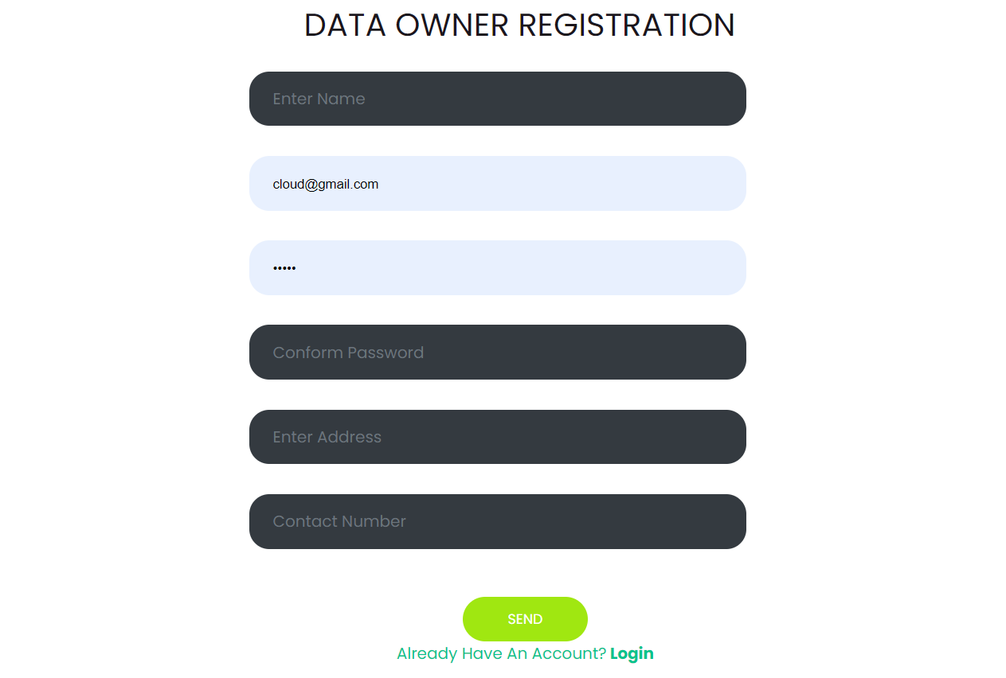

Login: The data owner can login with using valid credentials.

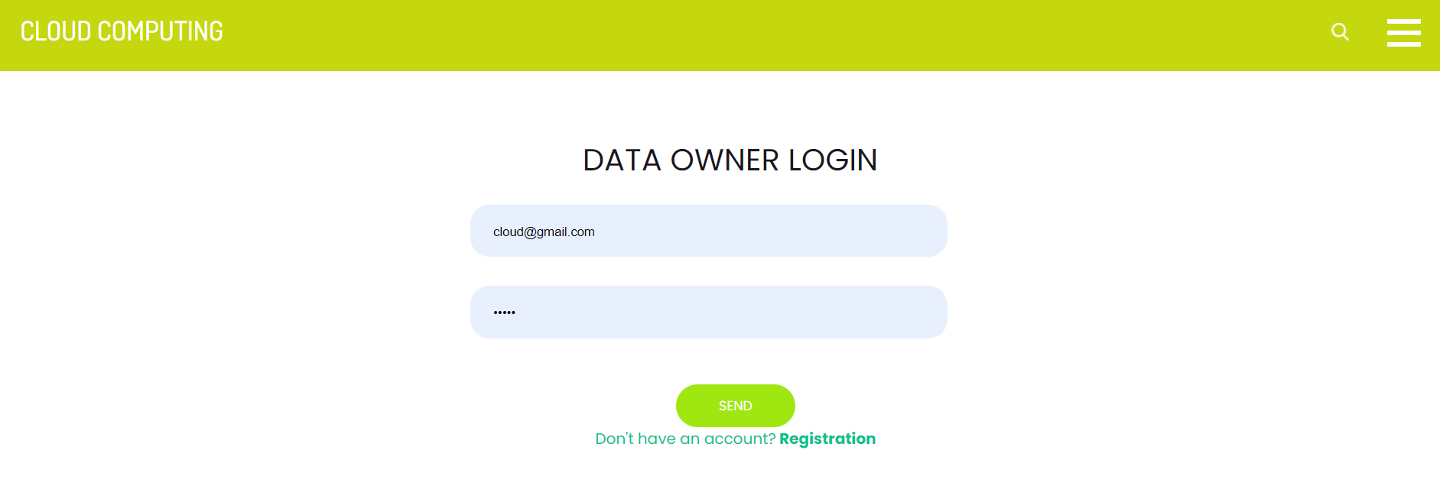

View profile: The data owner can view their profile.

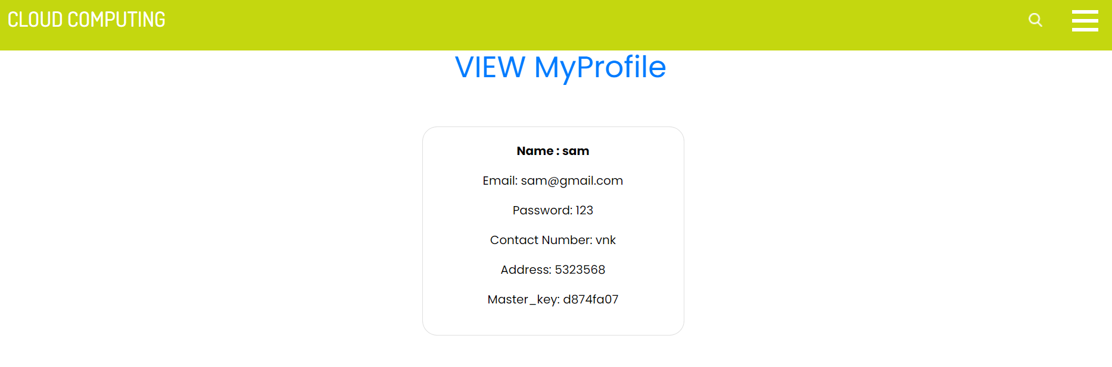
Request key: The data owner needs to request to key authentication for kay access.

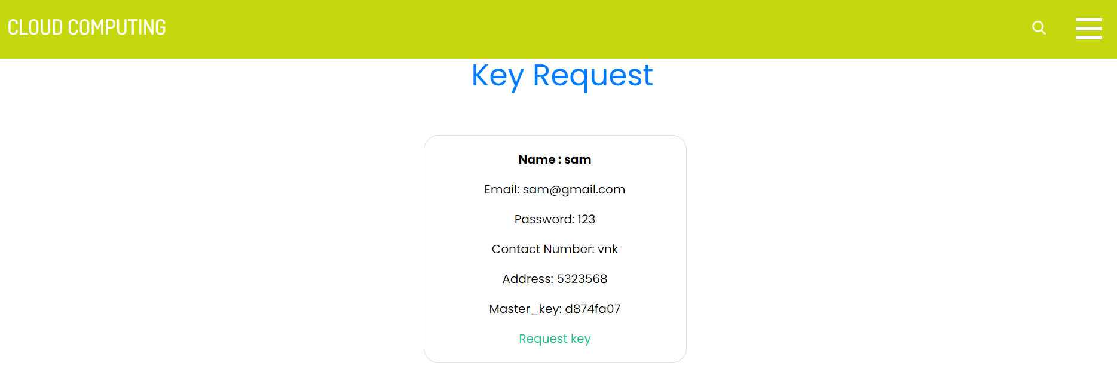
Upload file: The data owner can upload file to cloud with encrypting.

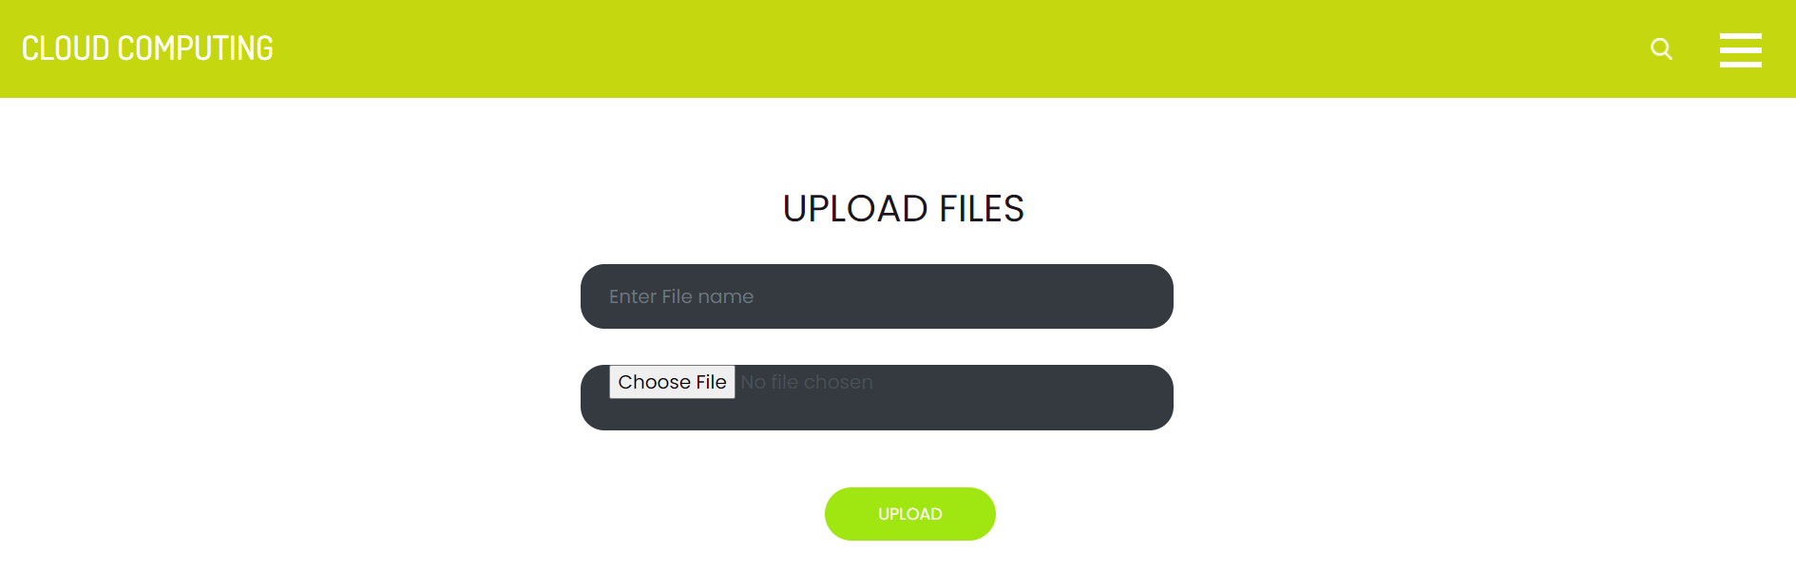

User Modules:

Sign up: The user needs to sign up with using the valid inputs.

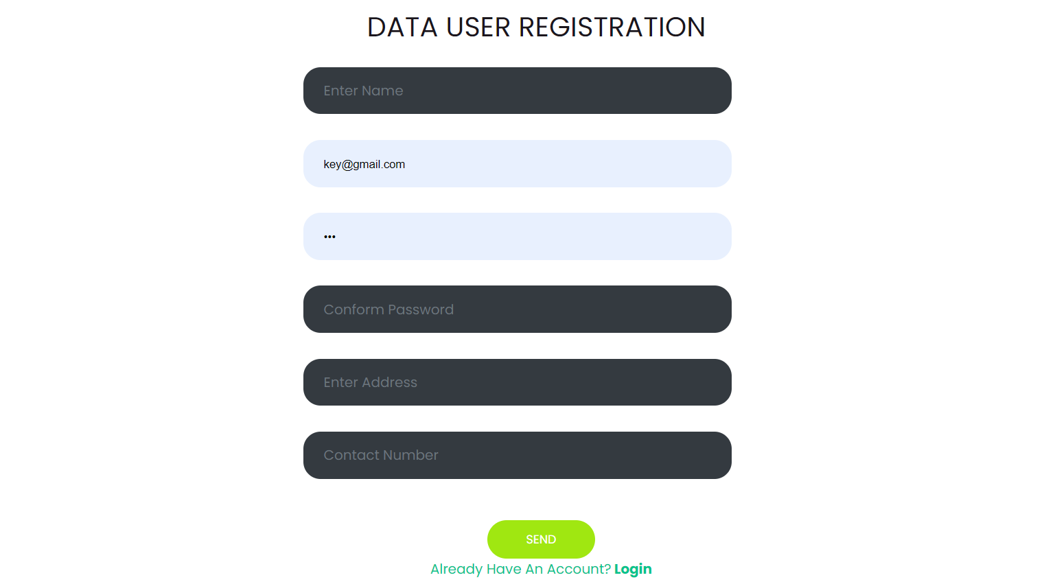

Sign in: The user can login with using valid credentials.

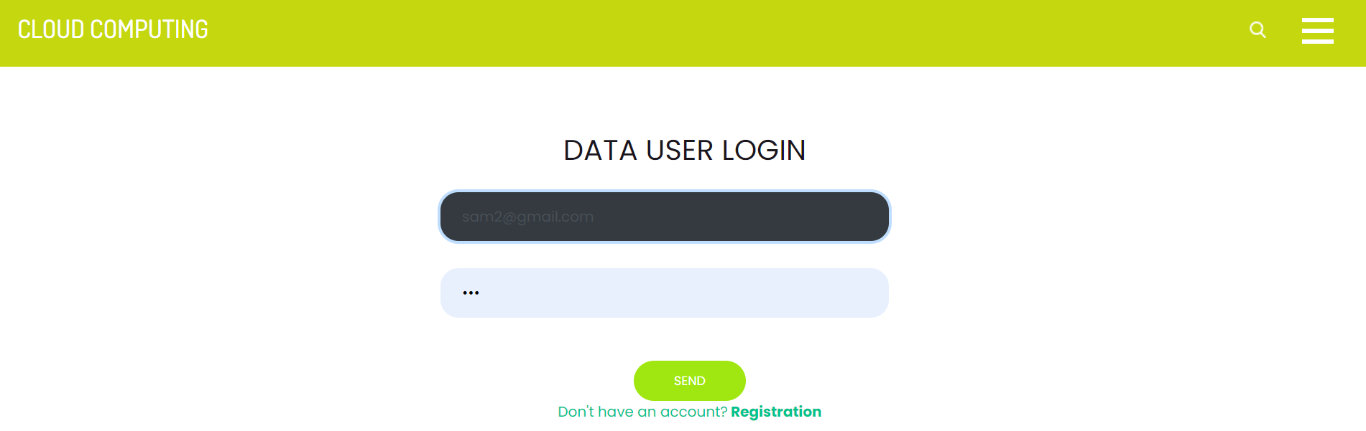
Search file: The user has a option to search files.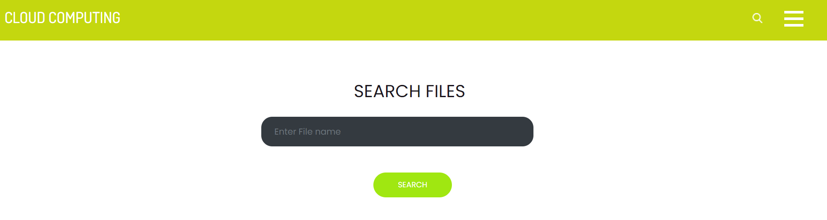

Send file request: The user need to send a file request for file access.

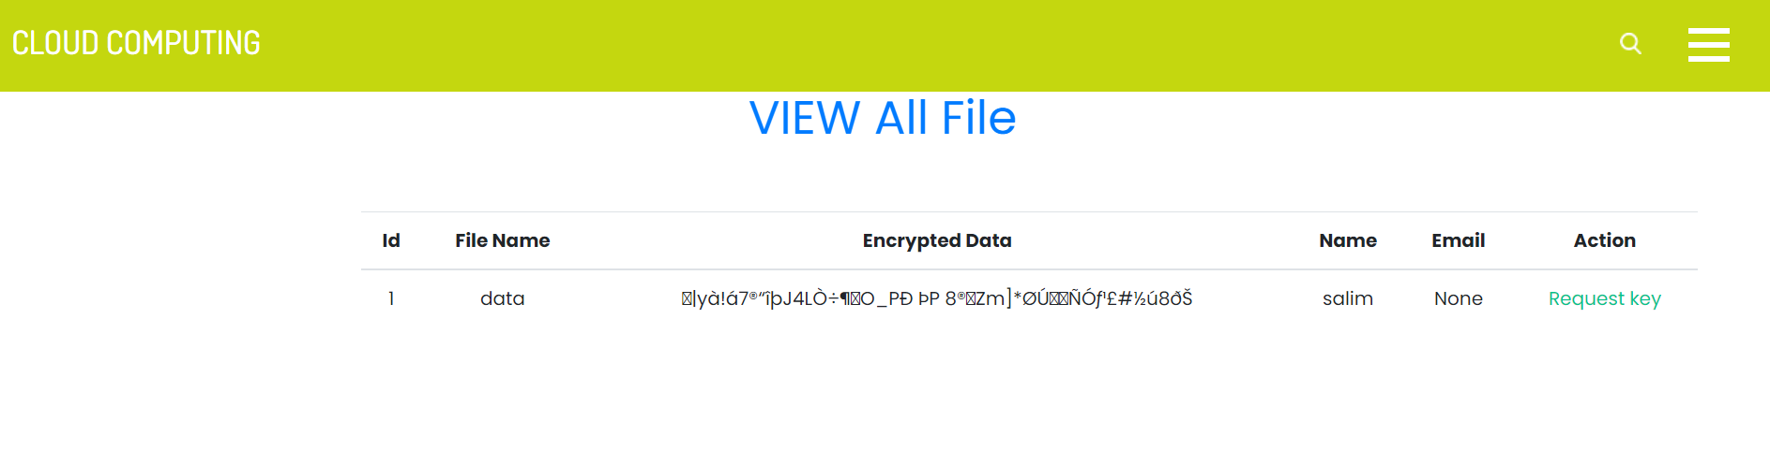

Decrypt& download file: After request approval the user ha a access to download the data.

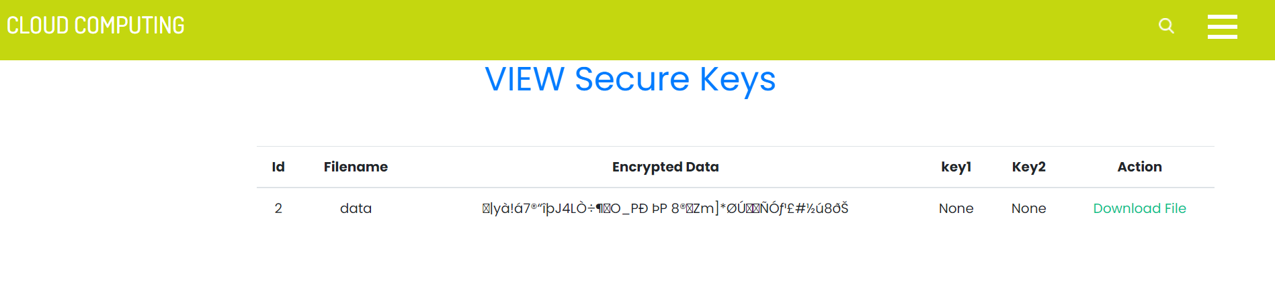

Logout: The users should be logout.

Key Authority Module:

Login: The key authority has default login credentials, authority can login directly.

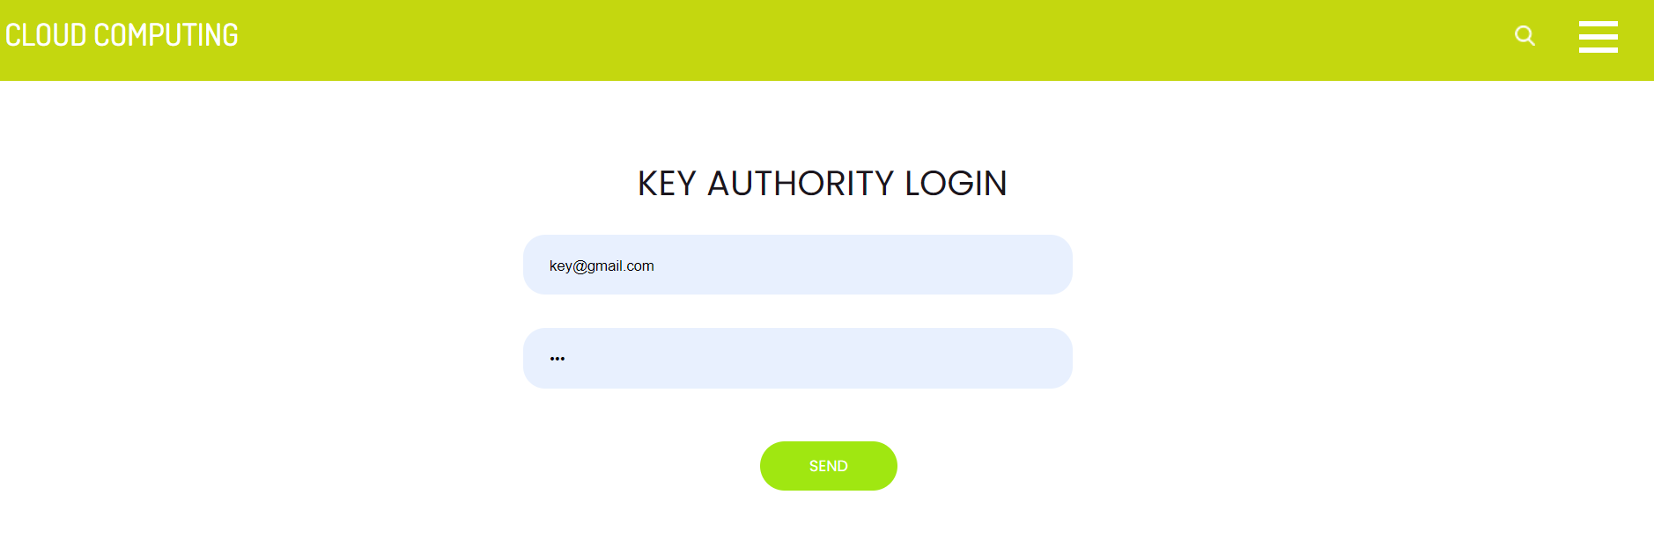

View key request: He can view the all request’s.

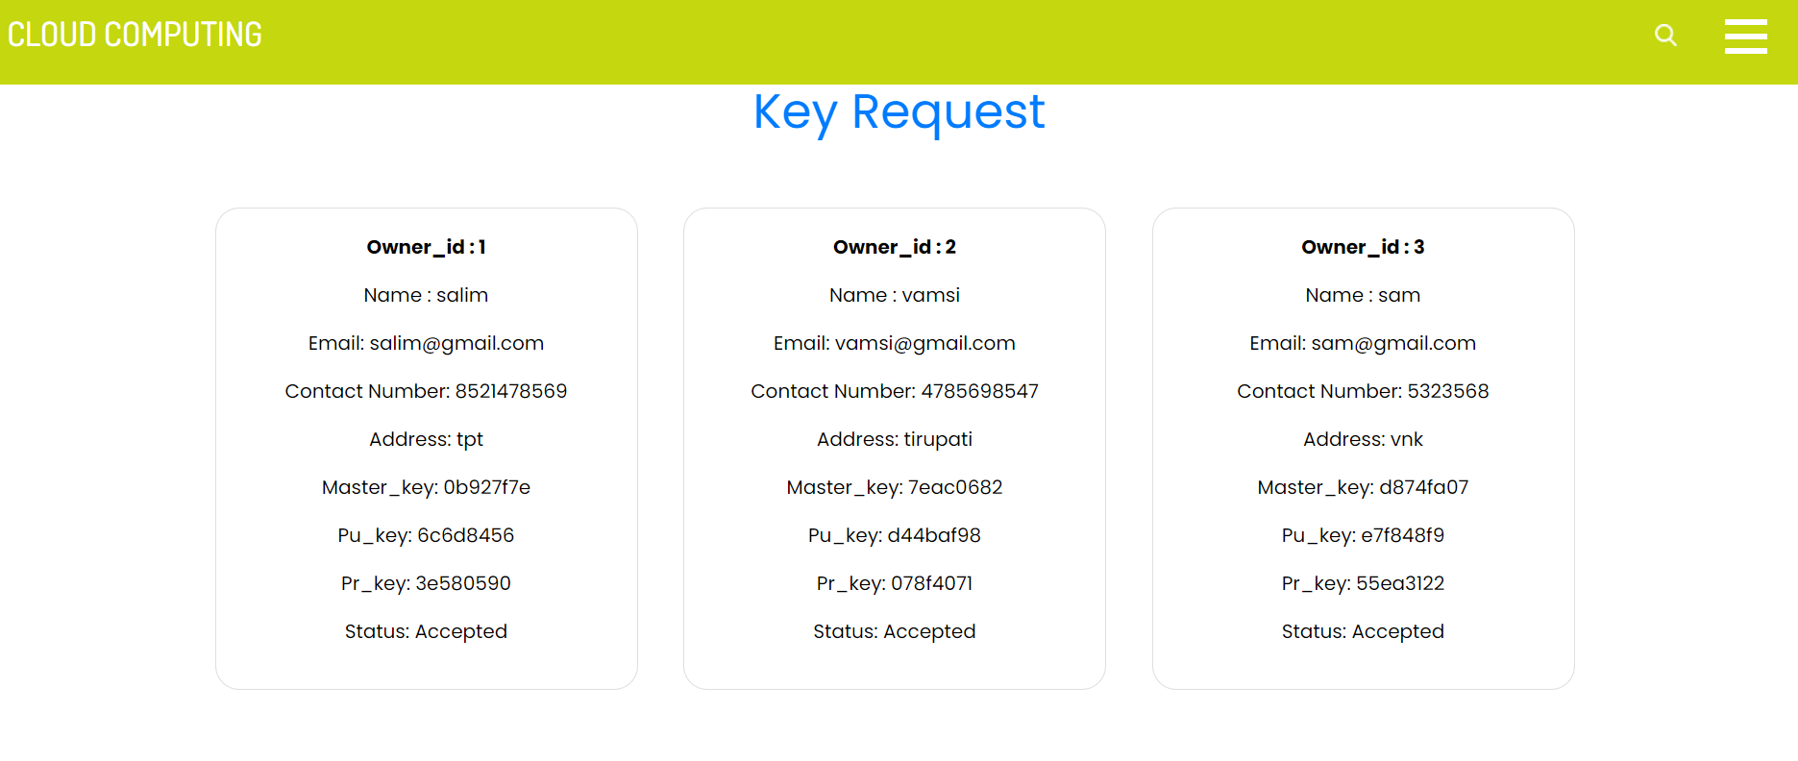

Provide key: The authority can provide the key to particular user.

Logout: The key authority should be logout.

Admin Module:

Login: The key authority has default login credentials, authority can login directly.

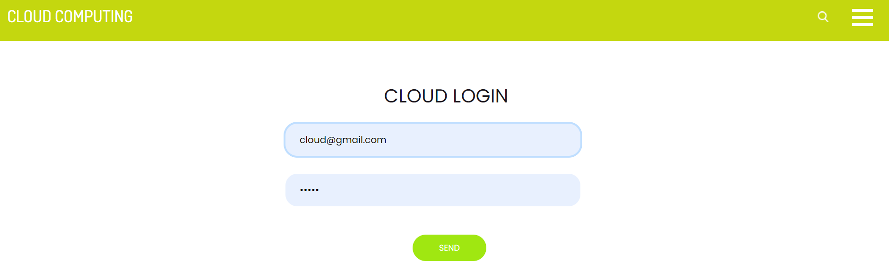

View key request: He can view the all request’s.

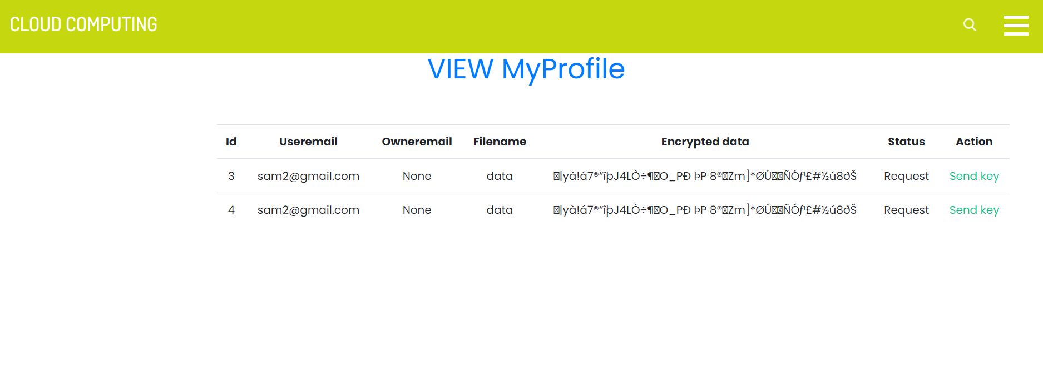
Provide key: The authority can provide the key to particular user.

Logout: The key authority should be logout.

RESULT:

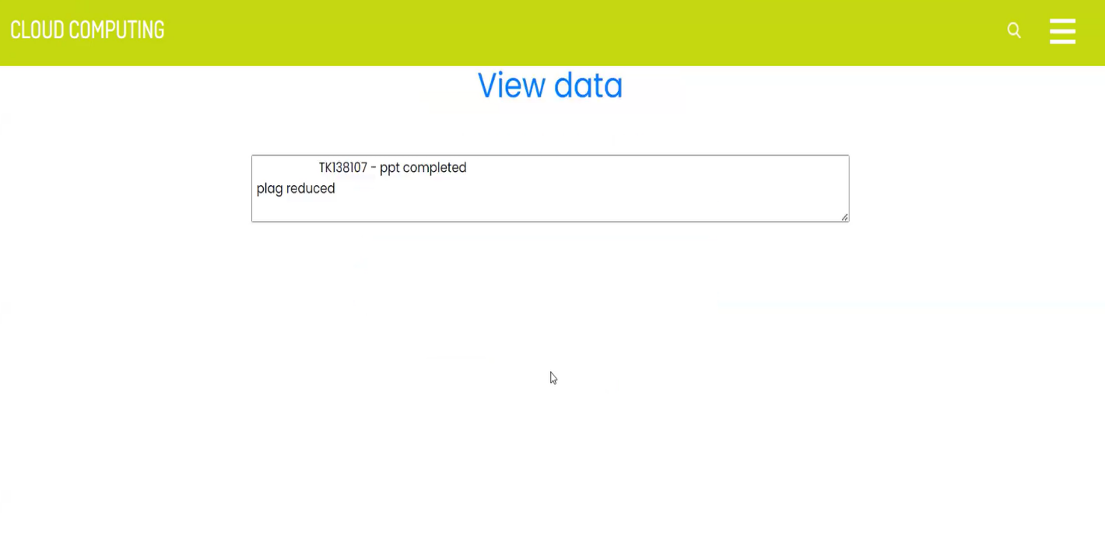

7. SYSTEM STUDY AND TESTING
7.1 Feasibility Study
The feasibility of the project is analysed in this phase and business proposal is put forth with a very general plan for the project and some cost estimates. During system analysis the feasibility study of the proposed system is to be carried out. This is to ensure that the proposed system is not a burden to the company. For feasibility analysis, some understanding of the major requirements for the system is essential.
Three key considerations involved in the feasibility analysis are
- Economical feasibility
- Technical feasibility
- Social feasibility
Economical Feasibility
This study is carried out to check the economic impact that the system will have on the organization. The amount of fund that the company can pour into the research and development of the system is limited. The expenditures must be justified. Thus the developed system as well within the budget and this was achieved because most of the technologies used are freely available. Only the customized products had to be purchased.

Technical Feasibility
This study is carried out to check the technical feasibility, that is, the technical requirements of the system. Any system developed must not have a high demand on the available technical resources. This will lead to high demands on the available technical resources. This will lead to high demands being placed on the client. The developed system must have a modest requirement, as only minimal or null changes are required for implementing this system.
Social Feasibility

The aspect of study is to check the level of acceptance of the system by the user. This includes the process of training the user to use the system efficiently. The user must not feel threatened by the system, instead must accept it as a necessity. The level of acceptance by the users solely depends on the methods that are employed to educate the user about the system and to make him familiar with it. His level of confidence must be raised so that he is also able to make some constructive criticism, which is welcomed, as he is the final user of the system.

System Testing
The purpose of testing is to discover errors. Testing is the process of trying to discover every conceivable fault or weakness in a work product. It provides a way to check the functionality of components, sub-assemblies, assemblies and/or a finished product It is the process of exercising software with the intent of ensuring that the
Software system meets its requirements and user expectations and does not fail in an unacceptable manner. There are various types of test. Each test type addresses a specific testing requirement.

7.2 Types of Tests

7.2.1 Unit testing
Unit testing involves the design of test cases that validate that the internal program logic is functioning properly, and that program inputs produce valid outputs. All decision branches and internal code flow should be validated. It is the testing of individual software units of the application .it is done after the completion of an individual unit before integration. This is a structural testing, that relies on knowledge of its construction and is invasive. Unit tests perform basic tests at component level and test a specific business process, application, and/or system configuration. Unit tests ensure that each unique path of a business process performs accurately to the documented specifications and contains clearly defined inputs and expected results.

7.2.2 Integration testing
Integration tests are designed to test integrated software components to determine if they actually run as one program. Testing is event driven and is more concerned with the basic outcome of screens

or fields. Integration tests demonstrate that although the components were individually satisfaction, as shown by successfully unit testing, the combination of components is correct and consistent. Integration testing is specifically aimed at exposing the problems that arise from the combination of components.
Software integration testing is the incremental integration testing of two or more integrated software components on a single platform to produce failures caused by interface defects.
The task of the integration test is to check that components or software applications, e.g. components in a software system or – one step up – software applications at the company level – interact without error.
Test Results: All the test cases mentioned above passed successfully. No defects encountered.

Acceptance Testing
User Acceptance Testing is a critical phase of any project and requires significant participation by the end user. It also ensures that the system meets the functional requirements.
Test Results: All the test cases mentioned above passed successfully. No defects encountered.

7.2.3 Functional testing
Functional tests provide systematic demonstrations that functions tested are available as specified by the business and technical requirements, system documentation, and user manuals.
Functional testing is centered on the following items:
Valid Input : identified classes of valid input must be accepted.
Invalid Input : identified classes of invalid input must be rejected.
Functions : identified functions must be exercised.
Output : identified classes of application outputs must be exercised.
Systems/Procedures: interfacing systems or procedures must be invoked.

Organization and preparation of functional tests is focused on requirements, key functions, or special test cases. In addition, systematic coverage pertaining to identify Business process flows; data fields, predefined processes, and successive processes must be considered for testing. Before functional testing is complete, additional tests are identified and the effective value of current tests is determined.

7.2.4 White Box Testing
White Box Testing is a testing in which in which the software tester has knowledge of the inner workings, structure and language of the software, or at least its purpose. It is purpose. It is used to test areas that cannot be reached from a black box level.

7.2.5 Black Box Testing
Black Box Testing is testing the software without any knowledge of the inner workings, structure or language of the module being tested. Black box tests, as most other kinds of tests, must be written from a definitive source document, such as specification or requirements document, such as specification or requirements document. It is a testing in which the software under test is treated, as a black box .you cannot “see” into it. The test provides inputs and responds to outputs without considering how the software works.
Test objectives
- All field entries must work properly.
- Pages must be activated from the identified link.
- The entry screen, messages and responses must not be delayed.
Features to be tested
- Verify that the entries are of the correct format
- No duplicate entries should be allowed
- All links should take the user to the correct page.

- TEST CASES:
Input | Output | Result
Input text files | File upload or not | Success

- Test cases Model building:
S.NO | Test cases | I/O | Expected O/T | Actual O/T | P/F
1 | Admin login | Enter email and password | Admin login successful | Admin login successful | P
2 | Upload file | Select file | File uploaded successful | File uploaded successful | P

8.CONCLUSION:

The proposed solution effectively addresses security concerns in Ciphertext-policy attribute-based encryption (CP-ABE) for secure cloud data sharing. By introducing a two-party key issuing protocol, it mitigates the key escrow problem, enhancing overall security. Additionally, the scheme improves attribute expressiveness through weighted attributes, reducing access policy complexity and improving data sharing efficiency. These advancements not only lower storage costs and encryption complexity but also ensure both security and efficiency in practical cloud applications.

9. FUTURE ENHANCEMENT

Integration of homomorphic encryption to further enhance privacy-preserving capabilities while maintaining efficiency. Exploration of blockchain technology for decentralized key management, ensuring enhanced resilience against single points of failure. Investigation into post-quantum secure cryptographic primitives to future-proof the system against quantum attacks. =In addition to these core enhancements, we will prioritize seamless integration of these technologies, ensuring minimal disruption to existing workflows while maximizing the benefits of enhanced security and privacy. By collaborating with leading experts and research institutions in the field, we will leverage cutting-edge advancements to inform our implementation strategies, ensuring that our system remains at the forefront of cryptographic innovation. Moreover, we will conduct thorough testing and evaluation procedures to validate the effectiveness and efficiency of these enhancements in real-world scenarios, guaranteeing robustness and reliability under diverse operational conditions. Our commitment to continuous improvement and innovation underscores our dedication to providing users with the highest standards of security, privacy, and resilience in an ever-evolving threat landscape. Through these strategic initiatives, we aim to position our system as a trusted cornerstone in the realm of secure data management, empowering individuals and organizations to harness the full potential of data-driven technologies with confidence and peace of mind.

10.REFERANCES

[1] J. Baek, Q. H. Vu, J. K. Liu, X. Huang, and Y. Xiang. A secure cloud computing based framework for big data information management of smart grid. IEEE Transactions on Cloud Computing, 3(2):233–244, 2015.
[2] A. Balu and K. Kuppusamy. An expressive and provably secure ciphertext-policy attribute-based encryption. Information Sciences, 276(4):354–362, 2014.
[3] M. Belenkiy, J. Camenisch, M. Chase, M. Kohlweiss, A. Lysyanskaya, and H. Shacham. Randomizable proofs and delegatable anonymous credentials. Proceedings of the 29th Annual International Cryptology Conference, pages 108–125, 2009.
[4] J. Bethencourt, A. Sahai, and B. Waters. Ciphertext-policy attributebased encryption. IEEE Symposium on Security and Privacy, pages 321–334, 2007.
[5] D. Boneh, B. Lynn, and H. Shacham. Short signatures from the weil pairing. Journal of Cryptology, 17(4):297–319, 2001.
[6] M. Chase. Multi-authority attribute based encryption. Proceedings of the 4th Conference on Theory of Cryptography, pages 515–534, 2007.
[7] M. Chase and S. S. Chow. Improving privacy and security in multiauthority attribute-based encryption. Proceedings of the 16th ACM Conference on Computer and Communications Security, pages 121–130, 2009.
[8] L. Cheung and C. Newport. Provably secure ciphertext policy ABE. Proceedings of the 14th ACM conference on Computer and communications security, pages 456–465, 2007.
[9] S. S. Chow. Removing escrow from identity-based encryption. Proceedings of the 12th International Conference on Practice and Theory in Public Key Cryptography, pages 256–276, 2009.
[10] C. K. Chu, W. T. Zhu, J. Han, J. K. Liu, J. Xu, and J. Zhou. Security concerns in popular cloud storage services. IEEE Pervasive Computing, 12(4):50–57, 2013.

ABSTRACT

This project aims to solve the severe communication gap between the hearing-impaired community and the general population through an AI-based bidirectional translation system. Traditional communication relies heavily on human sign language interpreters, limiting accessibility and independence for Deaf individuals.
The proposed Multi-Lingual Sign Language to Speech and Speech to Sign Translator provides a software-based solution leveraging Machine Learning, Natural Language Processing (NLP), and Computer Vision (CV). Operating via a standard webcam and microphone, the system utilizes MediaPipe Hand and Pose tracking to extract gesture landmarks, which are classified into accurate text using an advanced deep learning model. For bidirectional dialogue, the system captures spoken audio, employs Google Speech-to-Text for transcription, processes it through an NLP engine to map spoken grammar into Indian Sign Language (ISL) syntactical structure, and visually renders the translation using a 3D avatar animations.
The outcome is a highly accessible, multi-lingual web platform capable of recognizing complex gestures and converting them to regional speech while simultaneously translating audio input directly into real-time ISL gestures. This abolishes the reliance on costly sensor hardware, drastically improving independence and inclusivity.

TABLE OF CONTENTS

CHAPTER NO. | TITLE | PAGE NO.
1 | INTRODUCTION | 1
1.1 | Motivation | 1
1.2 | Problem Statement | 1
1.3 | Objectives | 2
1.4 | Scope | 2
1.5 | Overview of the System | 2
2 | LITERATURE SURVEY | 3
3 | SYSTEM ANALYSIS | 5
3.1 | Existing System | 5
3.2 | Disadvantages of Existing System | 5
3.3 | Proposed System | 6
3.4 | Advantages of Proposed System | 6
3.5 | Workflow Explanation | 6
4 | REQUIREMENT ANALYSIS | 8
4.1 | Functional Requirements | 8
4.2 | Non-Functional Requirements | 8
4.3 | Hardware Requirements | 9
4.4 | Software Requirements | 9
4.5 | System Architecture | 10
5 | SYSTEM DESIGN | 11
5.1 | Use Case Diagram | 11
5.2 | Class Diagram | 12
5.3 | Sequence Diagram | 13
5.4 | Activity Diagram | 14
5.5 | Component Diagram | 15
5.6 | Deployment Diagram | 15
5.7 | ER Diagram | 16
5.8 | Data Flow Diagram | 16
6 | CODE, IMPLEMENTATION AND RESULTS | 18
6.1 | Modules Overview | 18
6.2 | Sample Implementation Code | 20
6.3 | Output Screens | 22
7 | SYSTEM STUDY AND TESTING | 24
7.1 | Feasibility Study | 24
7.2 | Types of Testing | 24
7.3 | Test Cases | 25
8 | CONCLUSION | 26
9 | FUTURE ENHANCEMENT | 27
10 | REFERENCES | 28

1. INTRODUCTION

1.1 Motivation
According to global health records, millions of individuals navigate society primarily through sign language. Because the general public is unversed in sign vocabulary, the Deaf community faces profound societal isolation. Developing an autonomous, AI-driven software translating sign language to speech breaks this barrier natively without demanding users to wear intrusive sensors.
1.2 Problem Statement
Current interaction solutions between hearing and non-hearing individuals heavily depend on manual interpretation. Digital alternatives usually concentrate uniquely on American Sign Language while relying on high-cost hardware gloves. A lack of bidirectional functionality—meaning they translate signs to words but fail to translate spoken words back into sign patterns—renders daily conversational integration highly inefficient.
1.3 Objectives
1. Develop a bidirectional Sign-to-Speech and Speech-to-Sign translation system using Computer Vision.
2. Utilize MediaPipe arrays to dynamically recognize multi-hand structures substituting hardware layers.
3. Integrate Google Speech-to-Text establishing robust microphone transcription.
4. Design scalable multi-lingual pipelines permitting real-time vocalized outputs natively in regional languages.
1.4 Scope
The software bounds encompass isolated sign classification over a webcam matrix parsing direct NLP manipulations through Python pipelines. It enables users to switch localized vernacular outputs through a web interface, rendering audio and a dynamically mapped 3D avatar executing precise gloss motions accurately modeling Indian Sign Language mechanics.
1.5 Overview of the System
The system encapsulates both detection and rendering modules natively within web protocols. Camera streams feed isolated landmark features (hands, shoulders, elbows) matching complex gestures through integrated deep neural weights generating accurate strings. Subsequent text arrays trigger real-time Text-to-Speech functions mapping output sounds. Inversely, user audio feeds invoke Natural Language processing isolating the Subject/Object logic mapping resulting tokens rendering 3D avatar skeletal nodes executing translation sequences comprehensively.

2. LITERATURE SURVEY

[1] Sign Language Recognition utilizing CNN and LSTM Architectures
This model maps robust spatial characteristics avoiding the limitations of flat vector machines. However, it completely lacks speech synthesis endpoints mapping outputs strictly into basic text strings.

[2] MediaPipe Holistic Tracking within Real-time Computer Vision Systems
Highlights optimized browser extraction of human tracking points. It resolves physical boundary limits preventing users from wearing physical tracked gloves facilitating natural sign flow dynamics.

[3] Continuous Gesture Recognition mapping American Sign Language
Tracks dynamic sequences across complex lighting scenarios. Its primary limitation is the absolute isolation of its logic solely encompassing ASL preventing ISL adoption entirely.

[4] A Survey on Bidirectional Application Translation: Speech to Sign NLP
Validates transforming English syntax directly mimicking linguistic rules identifying verb modifiers isolating Subject/Object parameters effectively translating text outputs logically for Avatar ingestion constraints.

[5] Progressive Translators: End-to-End Hand Gesture Modelling
Investigates directly mapping text phrases directly to generated skeletal models minimizing rendering latencies highlighting why WebGL technologies successfully supersede native application render bounds.

[6] Implementing Multi-lingual Vocals mapping NLP strings via gTTS
Highlights programmatic methods utilizing regional speech identifiers configuring automated pitch modulations eliminating monolingual dependencies.

[7] Indian Sign Language Database Parsing and Implementation Algorithms
Addresses the severe dataset deficits found regionally demonstrating structural approaches mapping generalized Indian vocabulary nodes scaling accurate categorical modeling datasets.

3. SYSTEM ANALYSIS

3.1 Existing System
Current translation environments leverage sensor hardware tracking localized hand movements parsing standard ASL vocabularies returning fixed English interpretations lacking bidirectional interactions enabling deaf individuals to simultaneously understand speaking users independently.
3.2 Disadvantages of Existing System
• High Hardware Dependence: Restricts access strictly relying on expensive sensor nodes masking operational accessibility.
• Monolingual Bias: Hardcoded output processing limits global scaling preventing regional implementations significantly.
• Syntactical Incorrectness: Processing word-by-word without rearranging Subject/Object mapping yielding grammatically unviable visuals.
3.3 Proposed System
The proposed tool eliminates hardware leveraging web camera streams calculating node boundaries mapping predictive sequences leveraging customized ISL model weights resolving textual/vocal responses dynamically. Conversely, recording live mic data tokenizes phrasing matching structural Avatar parameters parsing real-time ISL visuals bi-directionally.
3.4 Advantages of Proposed System
• Zero Hardware Complexity: Bypasses flex-glove dependency operating smoothly over ubiquitous digital webcams natively.
• Universal Multi-Language Scaling: Embeds text integrations supporting massive dialect toggling simultaneously routing output syntaxes correctly.
• Real-time Grammar Engine: Transcribes audio correctly assigning token hierarchies modeling native OSV rules before translating avatar boundaries logically.
3.5 Workflow Explanation
The logical bounds configure initial client interactions routing user inputs specifically between a visual camera feed processing gesture mapping parameters mapping outputs toward deep-translation / Text-To-Speech interfaces directly. Alternatively, invoking the microphone processes Google Speech transcripts extracting core phrases mapping gloss rules outputting visual avatar bounds accurately mitigating inference limits reliably.

4. REQUIREMENT ANALYSIS

4.1 Functional Requirements
1. Web camera ingestion must extract and validate 258 coordinate dimensions natively tracking hand parameters.
2. Model operations must process sequence tracking mapping categorical predictions evaluating valid lexical sign tokens accurately.
3. Bidirectional logic processing microphone streams accurately logging strings evaluating syntactic language configurations outputting proper visual models.
4. Translating raw text into 8 regional formats parsing outputs mapping exact linguistic representations synthetically.
5. Tracking Dictionary progress managing dynamic point schemas indexing historical references continuously.
4.2 Non-Functional Requirements
• Low Latency Bounds: Ensuring end-to-end rendering logic evaluates predictions cleanly under 400ms mimicking actual conversation parameters natively.
• High Availability: Responsive deployments routing client rendering interfaces maintaining execution loops seamlessly handling interrupted signals gracefully.
• Security Integrity: Abstracted SQLite payloads managing local states encrypting internal registry passwords protecting backend routes effectively.
4.3 Hardware Requirements
• Central Processing Unit: AMD Ryzen 3 / Intel i3 baseline
• Allocation Memory: Minimum 8 GB internal RAM limits
• Audio/Video Nodes: Functional internal/external Webcam and Microphone endpoints.
4.4 Software Requirements
• Execution Tier: Python 3.10 and corresponding browser instances mapping HTML5 environments.
• External Library Chains: Flask REST bindings, OpenCV, MediaPipe tracking limits, SpeechRecognition.
• Synthesis Engines: Deep Translator APIs, Google Text to Speech module mapping parameters natively.
4.5 System Architecture
Client bounds manage capturing arrays configuring visual bounding interfaces communicating mapping sequences asynchronously transmitting validation payloads resolving REST API paths across global Flask bindings tracking localized session parameters tracking SQLite models outputting processed payload coordinates mapping localized HTML template hierarchies natively maintaining high operational responsiveness processing independent WebGL operations fluidly.

5. SYSTEM DESIGN

5.1 Use Case Diagram
Showcases user boundaries interacting completely over primary sub-components identifying Authentication layers feeding input structures directly initiating the translation pipelines evaluating logic parameters.
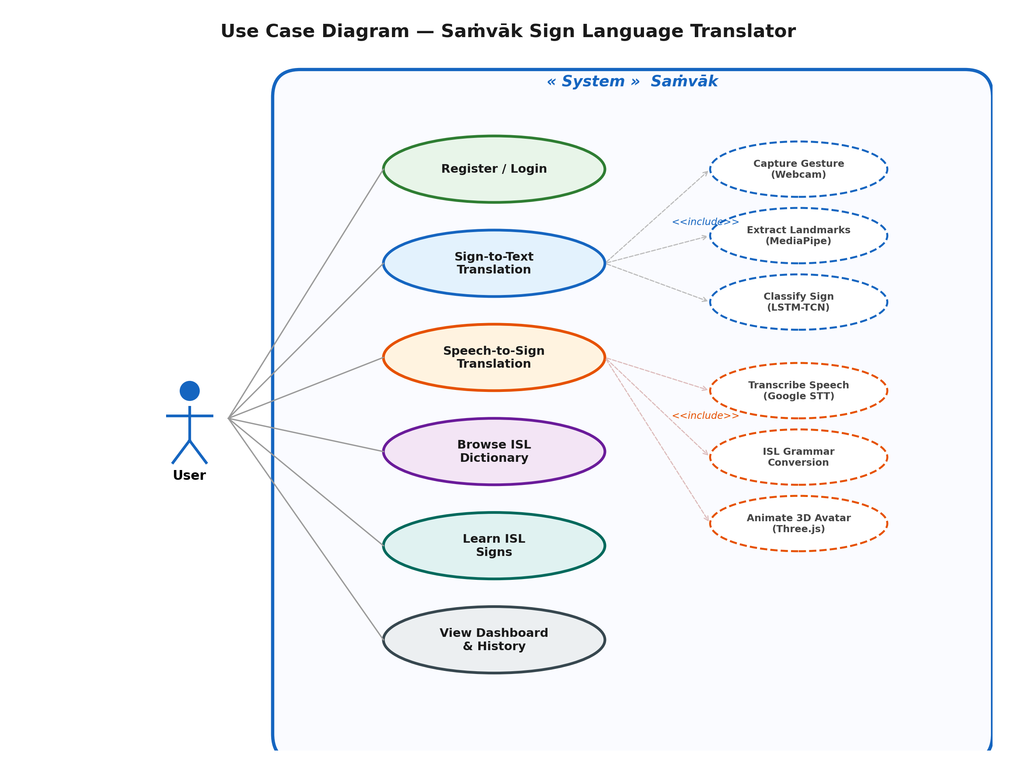
[Insert Diagram Screenshot Here]

5.2 Class Diagram
Translating operational classes linking logic structures outlining User Object persistence linking NLP grammar formatting boundaries passing model endpoints seamlessly.
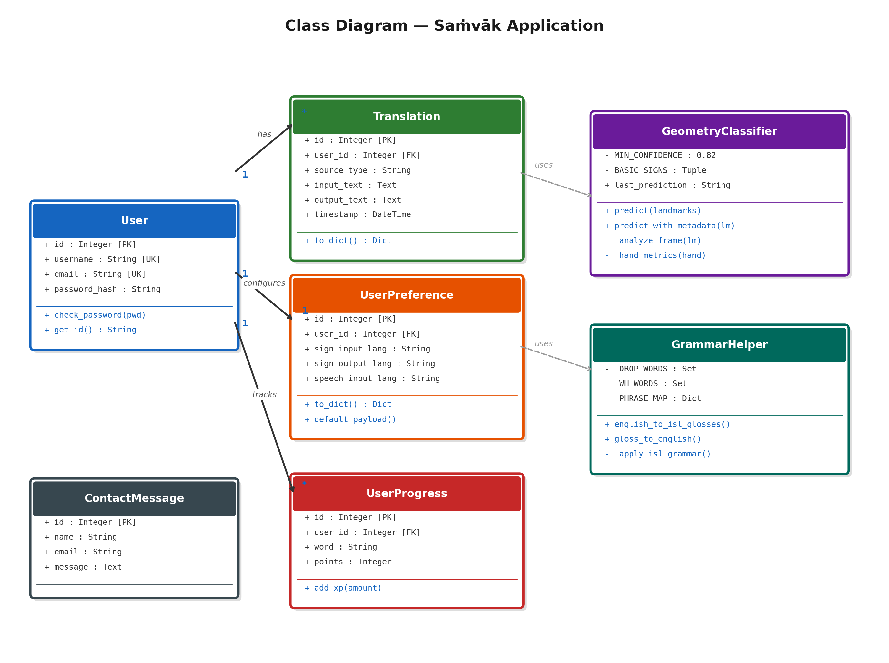
[Insert Diagram Screenshot Here]

5.3 Sequence Diagram
Evaluates mapping structures tracing Client boundaries initiating capture constraints passing prediction loops interacting comprehensively across logical translation processing states generating outputs properly.
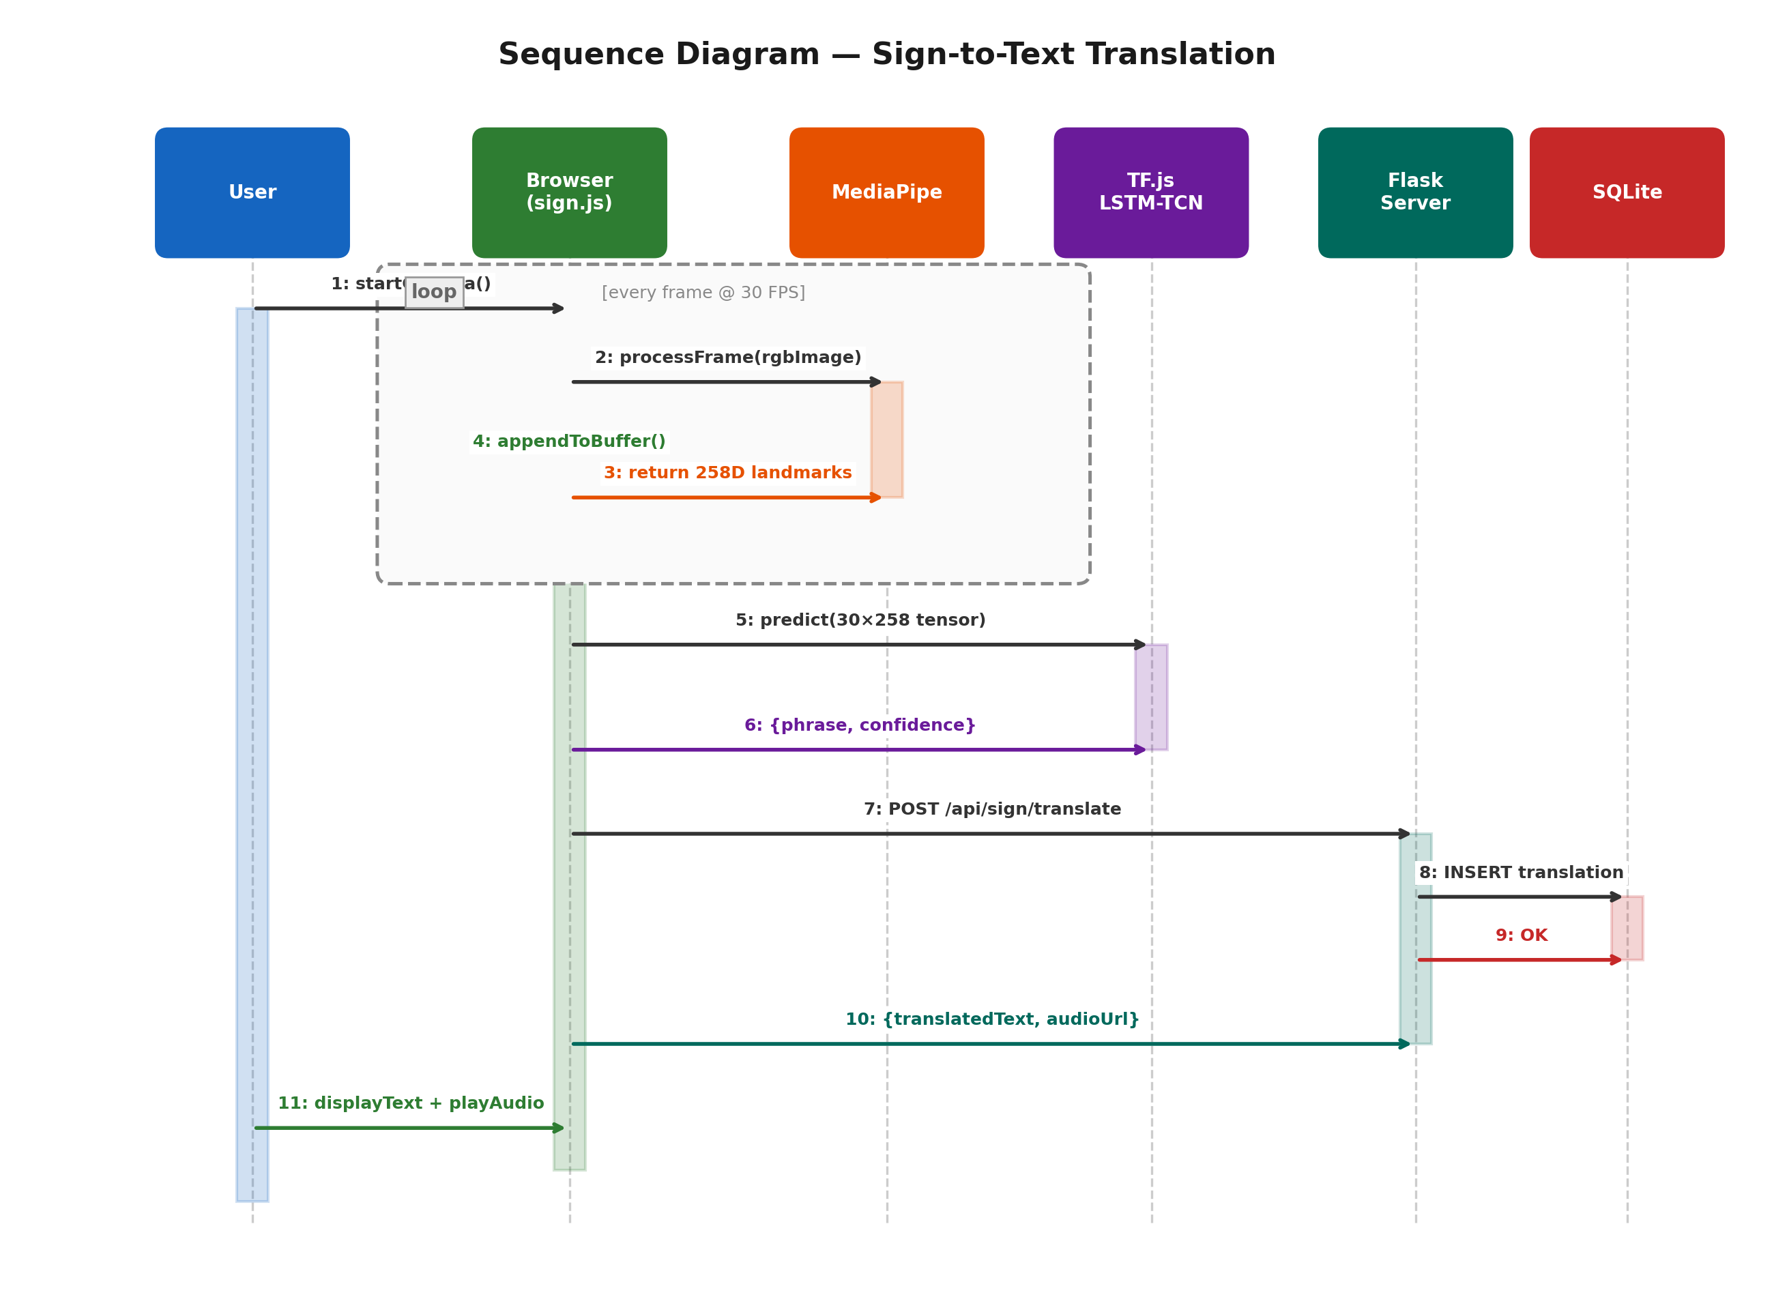
[Insert Diagram Screenshot Here]

5.4 Activity Diagram
Logs branch thresholds mapping conditional parameters generating accurate loop limits extracting frame sequences executing fallbacks predicting outputs correctly tracking system limits.
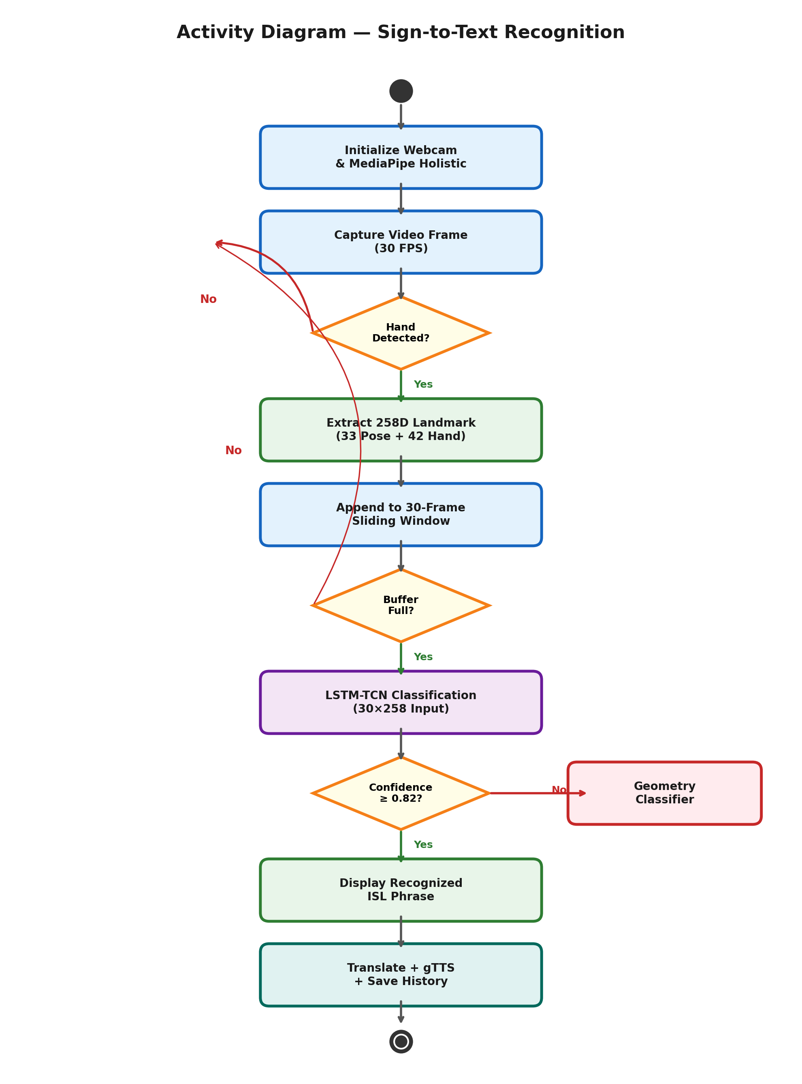
[Insert Diagram Screenshot Here]

5.5 Component Diagram
Identifies distinct logical blocks linking Web Client extraction modules passing processing structures into AI/NLP parsing engines configuring translation pipelines mapping backend states precisely.
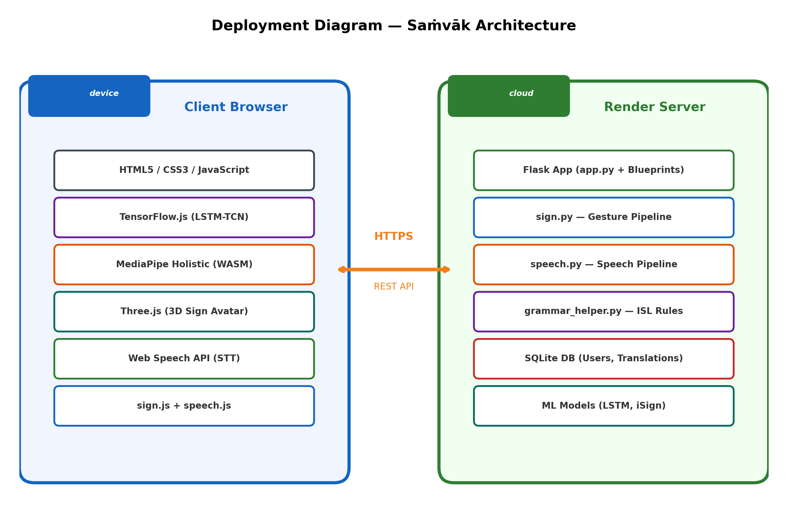
[Insert Diagram Screenshot Here]

5.6 Deployment Diagram
Evaluates physical machine constraints managing browser architectures feeding logical server operations parsing SQLite persistence files evaluating deployment hosts natively.

[Insert Diagram Screenshot Here]

5.7 ER Diagram
Plots data structures extracting Entity references outlining logic handling login records mapping Translation operations logging specific points configuring dictionary operations indexing natively.
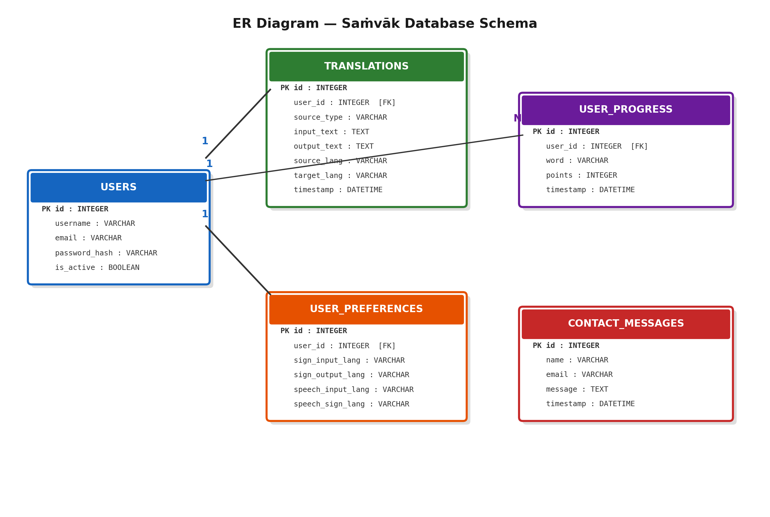
[Insert Diagram Screenshot Here]

5.8 Data Flow Diagram
Demonstrates the bidirectional data handling mapping specifically: User → Camera → Gesture Model → Text → Speech AND User → Mic → Speech → Text → Sign establishing processing operations logically tracking continuous state interactions isolating pipeline sequences.
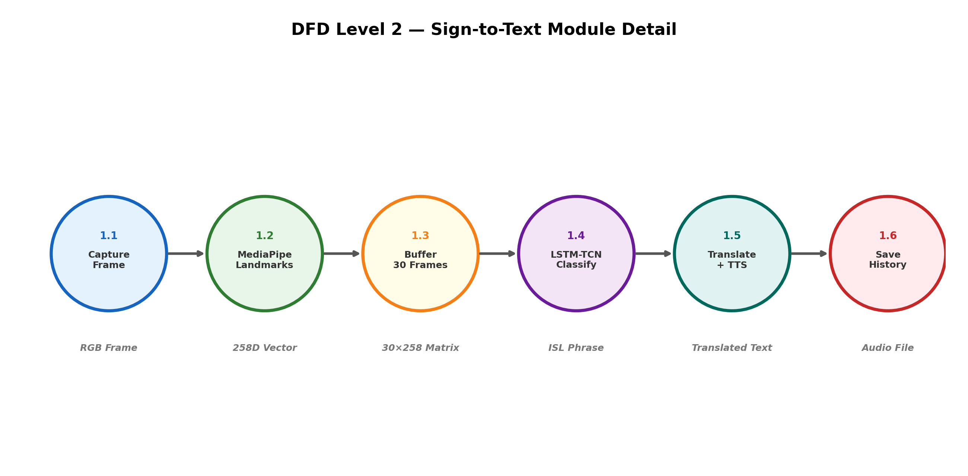
[Insert Diagram Screenshot Here]

